Precise Study On The Stretch Earrings

Starting with stretch earrings feels exciting and expressive. The journey begins slowly and calmly. Stretch piercing focuses on patience, comfort, and steady progress. Clean habits support healthy changes from the start. Many people begin using simple earring gauges for gradual movement. An ear stretcher helps guide the process gently. A lobe stretcher supports natural shape changes over time. Stretcher earrings offer an easy entry for beginners. Choosing stretched ear jewellery feels creative and personal. Ear stretcher jewellery adds style while keeping things relaxed. The beginning stage feels smooth, balanced, and encouraging for newcomers exploring change. Learning about stretch piercing step by step builds confidence. Each phase feels calm and manageable. Ear stretching gauges allow gradual spacing without pressure. Stretch earrings sit comfortably when patience guides progress. A relaxed pace supports happy results. Many choose a dead stretching kit for gentle expansion. Visit the below mentioned site, if you're looking for more information about stretch earrings.

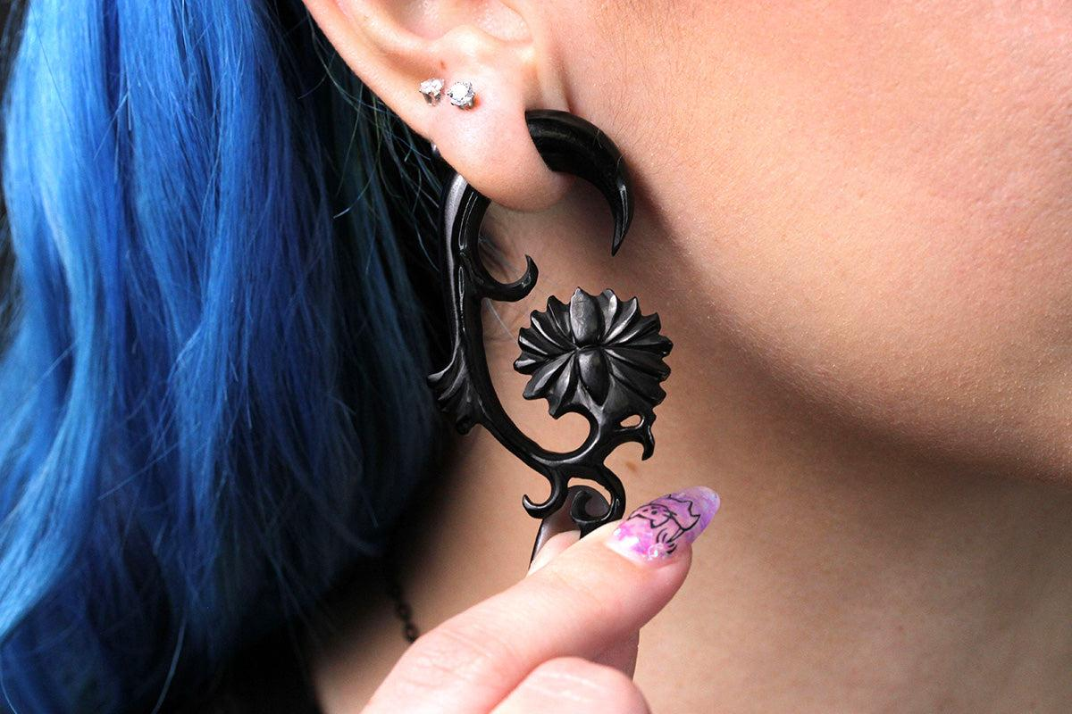

Dead stretching uses time rather than force. Dead stretching ears feel natural when handled with care. Dead stretching plugs offer smooth edges and comfort. This approach feels calm and controlled. Ear stretcher jewellery fits well during each stage. The experience feels steady, mindful, and positive throughout the entire beginning journey. Comfort matters during early stretching stages. Stretch earrings feel light and supportive when chosen wisely. Stretch piercing encourages listening to natural responses. Soft materials feel pleasant during daily wear. Earring gauges help keep spacing consistent and even. A lobe stretcher supports gradual adjustment comfortably. Stretcher earrings feel easy during movement and rest. Dead stretching focuses on calm progress. Dead stretching ears adapt gently over time. Dead stretching plugs feel smooth and balanced. This method encourages patience and ease. Stretched ear jewellery becomes part of daily style, offering confidence and relaxed self expression. Choosing the right tools builds a smooth experience.

An ear stretcher offers guidance and comfort. Ear stretching gauges help maintain even movement. Stretch earrings suit everyday wear with ease. Stretcher earrings allow gentle transitions. A dead stretching kit supports a relaxed approach. Dead stretching promotes slow and steady growth. Dead stretching ears adjust naturally with time. Dead stretching plugs feel comfortable throughout the day. Lobe stretcher use feels supportive and balanced. Ear stretcher jewellery blends function and style. Stretched ear jewellery becomes a calm extension of personal expression and creative identity during early stages. Starting slowly creates a positive stretching journey. Stretch piercing feels rewarding with patience. Stretch earrings offer comfort and style together. Earring gauges support gentle spacing. An ear stretcher guides movement naturally. Lobe stretcher use feels steady and relaxed. Stretcher earrings fit well during daily routines. A dead stretching kit encourages calm progress. Dead stretching focuses on time and ease. Dead stretching ears adapt smoothly. Dead stretching plugs feel gentle and secure. Ear stretching gauges maintain balance. Ear stretcher jewellery enhances appearance. Stretched ear jewellery reflects creativity, confidence, and personal growth through mindful beginnings.

