Facts About Gaming Bus Party

The rise of mobile gaming events began with simple setups that offered quick fun for groups. Small gatherings grew into organised moments that used compact screens and easy gear. Over time, creative hosts discovered new ways to deliver playful experiences through flexible layouts. This shift led to early forms of the mobile gaming van and shaped the path toward the modern gamers truck. Each new idea inspired the next stage, creating friendly spaces for relaxed enjoyment. These moments slowly developed into full features now seen in a gaming bus party or gaming van party, bringing shared entertainment to many celebrations. As interest grew, guests wanted more variety, smoother play, and a more complete setup. Simple layouts changed into themed zones inside a bright gaming van or a spacious unit designed for fun. If you are looking for additional info on gaming van, go to the above website.

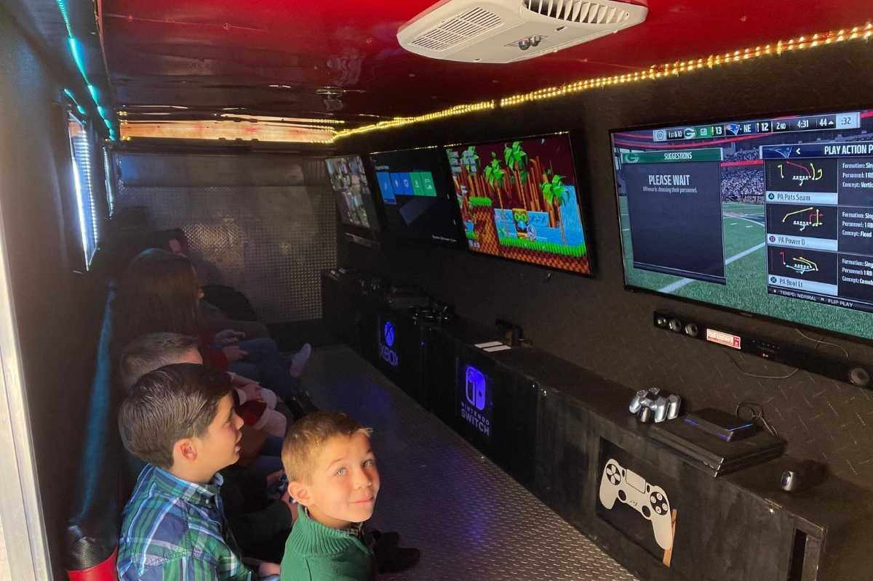

Hosts saw how a gaming truck for parties could create a lively setting that suited many styles. Smooth seating, soft lighting, and easy controls helped shape an inviting feel for all ages. Many groups enjoyed how the gaming bus for parties delivered playful moments in one neat space. These choices paved the way for advanced features found in newer builds. The trend continued as families and groups searched for friendly and joyful ways to celebrate. A gaming van birthday party became a popular choice because it created lasting memories without effort. Smooth plans, flexible layouts, and simple ideas made it suitable for different themes. A gaming van for parties offered a safe and cosy place for friendly matches. People appreciated how each setup created cheerful moments. The arrival of the ultimate beast gaming bus added fresh excitement with a bold style and vibrant zones. The growing demand encouraged more hosts to explore creative designs. Convenient booking also helped the trend move forward.

Easy access to gaming bus hire or gaming truck hire made planning smoother for many groups. People valued simple schedules and clear plans that kept things stress-free. A mobile gaming van could reach various venues, making the process flexible. Hosts enjoyed delivering fun without complicated setups. This made these units ideal for many gatherings. Each option created friendly, warm, and fun moments for guests of different ages. The smooth service and balanced features helped create trust in these mobile party experiences. Today, mobile gaming events continue to grow with bright features and inviting themes. A gamers truck or gaming van now brings a complete experience with a cosy feel. Guests enjoy the charming setting inside a gaming bus party or gaming van party. Each option offers a simple way to enjoy shared play without heavy planning. A gaming truck for parties or gaming bus for parties adds vivid energy to many events. Easy access to gaming bus hire and gaming truck hire supports smooth planning. These ideas continue to shape celebrations through lively travel-friendly entertainment.

