Detailed Report On Volvo DPF Emulator

The use of an emulator in modern vehicles helps create steady and reliable system behavior. Many operators look for simple ways to keep functions stable, so they choose tools that offer a clear and predictable response. An emulator Euro 6 option supports smooth operation without adding complex steps. A DAF emulator is often used when consistent signals are needed across different parts of the system. These tools help maintain balance in daily use and reduce disruptions. Their purpose is to provide an easy method for maintaining steady performance in various conditions without unnecessary complications or technical demands. A growing number of users select an emulator for DAF truck setups because they want dependable behavior with minimal adjustment. These tools help the vehicle respond as expected, offering a uniform approach for many situations. Visit the below mentioned site, if you are hunting for more details regarding volvo adblue emulator.

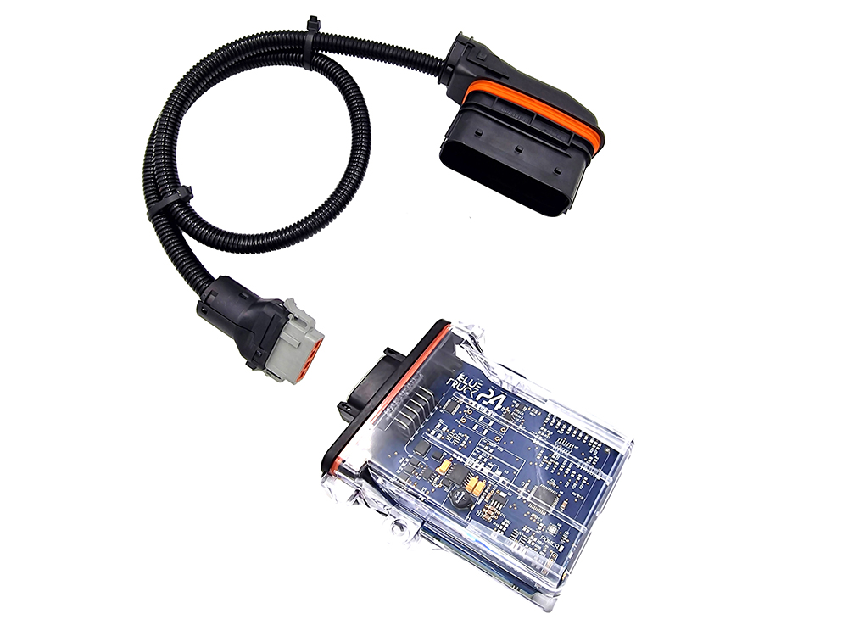

A D13 DPF emulator is valued for producing clear signals that help the system work without sudden changes. People appreciate these devices because they support smooth function. By keeping processes predictable, the truck continues to operate in a controlled manner. Many operators find this helpful because the environment can change, but the response remains stable. Different systems often benefit from well-designed tools, and an emulator DAF XF 105 solution offers simple support for that model. Users look for uncomplicated stability, and these devices help the system behave in a steady way each time. A DAF XF 105 emulator creates a comfortable balance that prevents irregular reactions. This structure allows the vehicle to follow consistent patterns that make daily tasks easier. Many operators rely on these tools because they want function without interruptions. Their value comes from providing predictable outcomes with minimal effort or adjustment. There is also steady demand for a DAF LF emulator, which helps maintain the harmony of internal processes.

Different truck models require different levels of support, yet the purpose stays similar across all tools. These devices bring clarity to various signals within the system. Users appreciate the uniform approach that helps produce smooth interactions throughout the vehicle. The goal is always a stable experience that does not depend on changing conditions. These tools help bridge gaps that may appear in operation and offer steady guidance. Together, these solutions show how various emulator options support different systems with easy methods. Each device brings a sense of order, helping operators control internal reactions more effectively. With an emulator, an emulator Euro 6, a DAF emulator, an emulator for DAF truck, a D13 DPF emulator, an emulator DAF XF 105, a DAF XF 105 emulator, or a DAF LF emulator, the user gains a balanced experience that keeps vehicle behavior consistent. These tools create calm operation, reduce unexpected shifts, and help maintain smooth function. Their shared goal is to make every task feel easier.

