Detailed Analysis On Fire Barriers

Fire protection begins with understanding the basics before moving into advanced solutions. Fire barriers form a key foundation in safety planning, helping to slow the spread of fire and smoke. Fire safety barriers work by creating protected sections within structures. A complete fire barrier system supports safer environments by limiting damage and improving response time. Proper fire barrier installation ensures these systems work as intended. Alongside this, fire stopping plays an important role in sealing gaps and openings. Fire stopping systems help maintain safety by preventing fire movement through hidden spaces, supporting overall building protection. As fire protection develops, compartment-based approaches become essential. Fire compartmentation divides buildings into controlled sections to reduce fire spread. Compartmentation fire protection supports safer evacuation and improved containment. If you're searching to learn more about fire barriers, take a look at previously mentioned website.

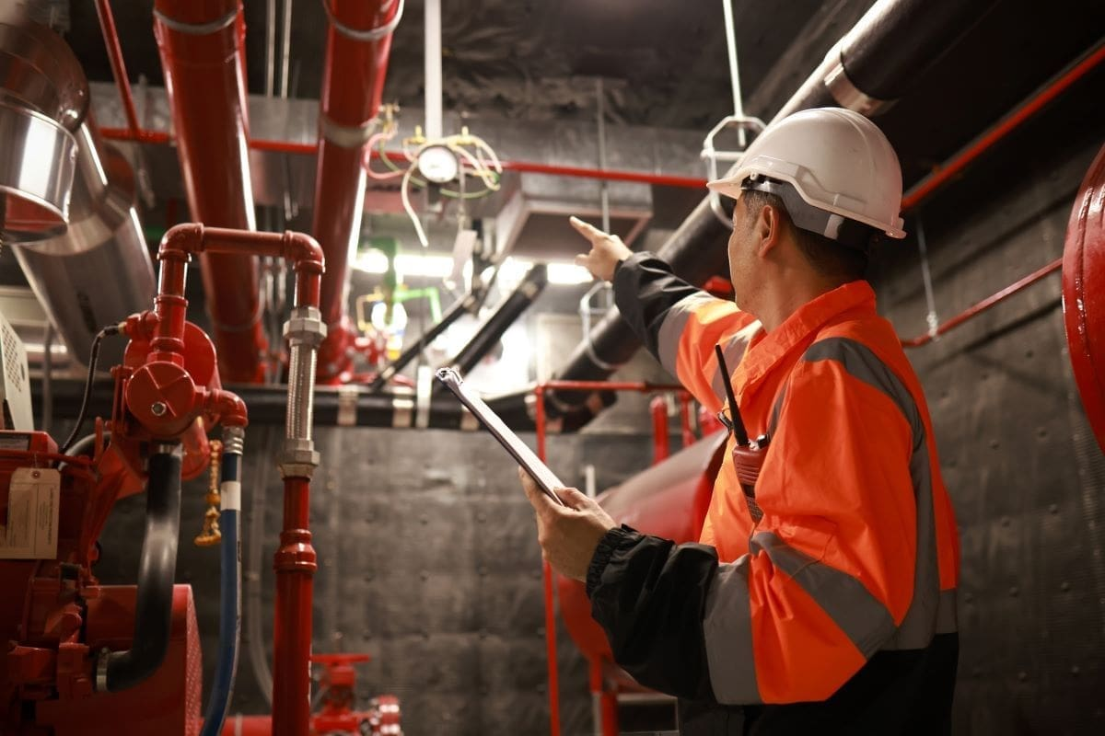

Building fire compartmentation is widely used to protect both occupants and property. Fire stopping installers help ensure barriers and seals are correctly applied. Fire stopping systems work together with fire compartmentation to create layered defence. These measures form the backbone of effective safety planning. When correctly designed, they provide long-term reliability and peace of mind while supporting modern construction standards and evolving safety expectations. Advanced fire protection also focuses on hidden and external areas. Cavity barriers in external walls help prevent unseen fire spread within wall spaces. These barriers are vital for maintaining safety across multiple levels. EWS1 cladding assessments have increased awareness around external materials and their performance. External fire resistant cladding supports safer building envelopes by limiting flame spread. These advanced elements work alongside internal systems to provide complete protection. By combining cavity control and resistant materials, modern fire strategies address risks that basic measures alone may not fully manage. Outdoor and structural features also require careful fire planning. Non combustible composite decking is increasingly used to reduce fire risk in exposed areas.

Non combustible balcony decking supports safety while maintaining durability and design flexibility. Fire rated decking adds an extra layer of protection by slowing ignition and spread. These materials complement fire safety barriers by extending protection beyond internal spaces. When combined with internal fire barrier systems, they help create a safer overall structure. Advanced fire planning considers every surface, ensuring consistent protection throughout all usable areas. Understanding both basic and advanced fire protection creates a stronger safety strategy. Fire barriers, fire stopping, and fire compartmentation provide essential internal control. Fire stopping installers and fire stopping systems ensure proper application and performance. External solutions such as cavity barriers in external walls and external fire resistant cladding strengthen protection further. Materials like non combustible composite decking, non combustible balcony decking, and fire rated decking support safety across all areas. Together, these measures form a complete approach that balances foundational protection with advanced solutions for long-term fire safety and structural resilience.

