A Little Bit About Premium Video Production

Videography holds strong value today because moving images create clear messages that feel real. People connect with scenes that show mood and meaning. Many search to find a videographer who can bring ideas to life through simple shots and smooth edits. Skilled videographers shape stories that feel natural and easy to follow. Their work helps groups share messages with calm confidence. Clear visuals build trust and spark interest. A video editor adds harmony and balance to each scene, giving every frame purpose. These combined skills help videos reach more people with ease and steady impact. Many creators rely on a freelance videographer because flexible support offers wide benefits. A freelance cinematographer brings fresh style through simple visual choices that guide attention. These creative talents use general tools to capture moments that feel warm and inviting. Companies often value freelance video production because it adapts to shifting needs with ease. Are you searching about freelance cinematographer? Browse the earlier outlined website.

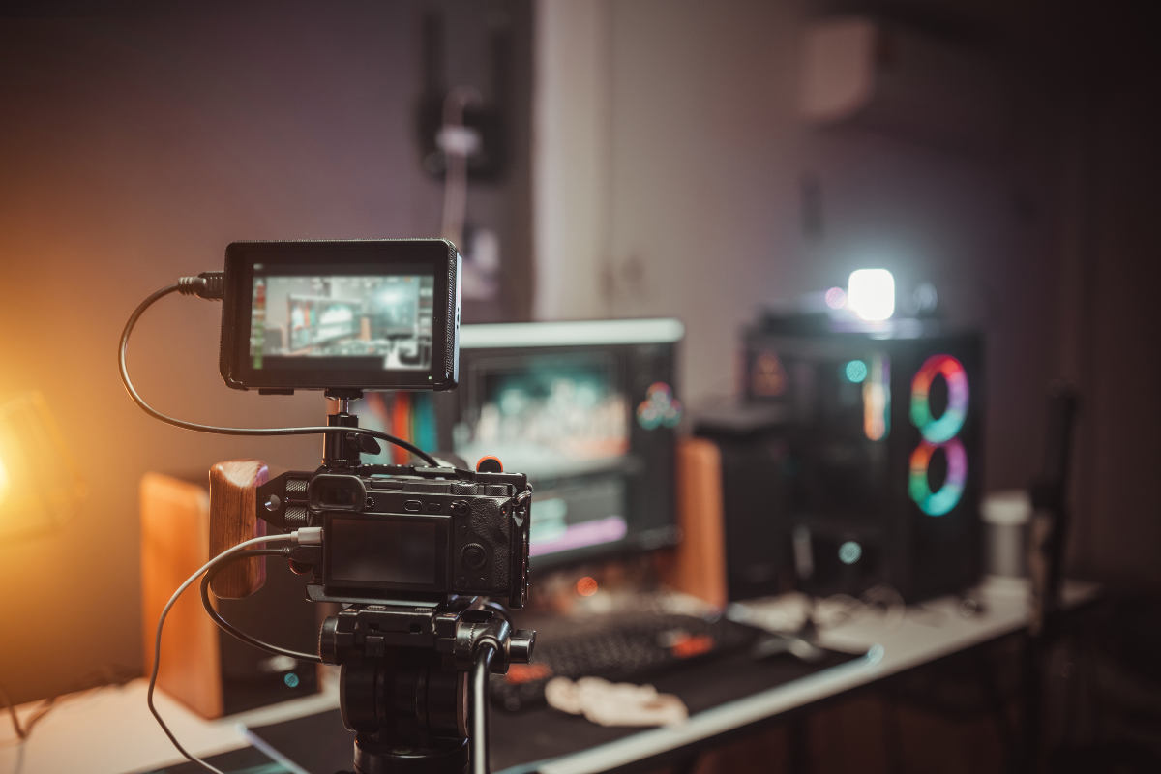

Smooth edits from a freelance videographer editor help improve each project. Skilled support helps shape clear stories that feel full and expressive. This steady rise of freelance work shows how visual content holds growing influence across many fields. Modern demand also highlights how an independent videographer brings unique value through personal vision. This approach creates simple scenes filled with clear tones and gentle flow. Many people like to work with an independent brand videographer because the process feels direct and open. Stories become stronger when one person shapes the message with steady focus. A professional videographer freelance option offers freedom and simple support. These creators guide each step with calm care and thoughtful choices. Their smooth way of working helps ideas grow into meaningful visual stories for many uses. The role of videographers continues to expand as new needs appear. People want clear images that express feeling through natural light, soft motion, and gentle pacing. Teams often find a videographer who can provide calm guidance during planning.

A video editor adds clean rhythm that lifts the message and supports every scene. Freelance video production offers flexible options for groups of all sizes. Many creators choose an independent videographer because the process feels open and expressive. These trends show how visual work shapes clear messages that support growth and communication. As demand grows, many now blend roles to offer simple and complete support. A freelance videographer editor delivers smooth results because shooting and editing stay closely linked. An independent brand videographer guides messages with gentle focus and balanced style. A freelance cinematographer adds depth through simple visual choices. A professional videographer freelance option offers flexible planning that supports many ideas. Modern videographers create work that feels honest and expressive. Their influence grows as people seek clear stories that connect with calm strength. This rise shows why videography remains a powerful tool for communication today.

