A Glimpse At Mobile Massage Service

Mobile massage offers a calm way to enjoy relaxing care anywhere. These mobile massage services bring gentle support straight to a chosen space. Many people enjoy a massage at home because it feels peaceful and familiar. Others prefer a hotel room massage during travel for extra comfort. Each option gives steady relief through simple methods. Mobile massage bookings make the whole process easier and quicker. A mobile massage therapist brings soothing skills to any setting. Some clients choose a massage near airport areas for ease. Many also enjoy mobile sports massage for flexible wellness support. Each service brings comfort through simple routines. Home massage offers a quiet setting with soft comfort. People enjoy massage at home because it keeps things calm. The space feels safe, warm, and relaxed. Mobile massage services create a smooth experience with simple steps. Each mobile massage therapist provides gentle care with easy, flowing movements. Are you hunting about mobile massage london uk? Visit the previously outlined site.

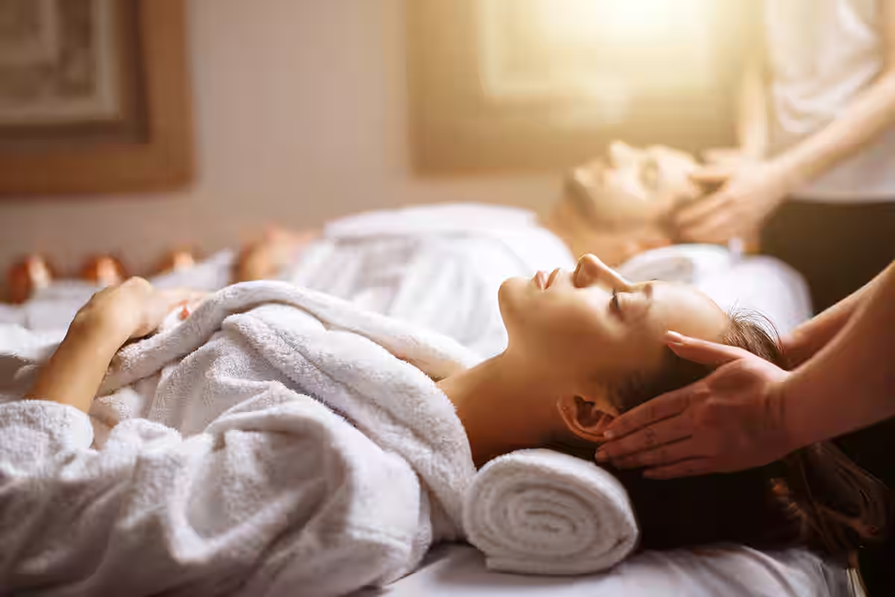

Hotel room massage helps travellers unwind with calm attention. Mobile massage bookings keep the process simple for everyone. A massage near airport locations adds extra convenience for moving guests. Many also enjoy mobile sports massage for flexible support. These choices help many people enjoy peaceful sessions anywhere. Mobile massage provides a wide mix of soothing choices. The care stays adaptable and smooth. A massage at home brings comfort with familiar surroundings. Home massage helps create calm moments. Mobile massage services keep things effortless from start to finish. Hotel room massage offers gentle support during travel, with soft energy. A mobile massage therapist works with simple routines that feel natural. Mobile massage bookings make the process quick. A massage near airport areas supports travellers who want comfort. Mobile sports massage adds easy movement support. These simple options help people enjoy steady relaxation. People choose mobile massage because the service feels easy. A massage at home provides a peaceful space.

Home massage creates quiet rest with gentle attention. Mobile massage services keep the process smooth. Hotel room massage offers calm relief during trips. A mobile massage therapist adapts the session to the space. Mobile massage bookings help people arrange sessions without stress. A massage near airport spots brings comfort for travellers. Mobile sports massage supports active people with steady support. Each service adds convenient calm. The range gives everyone simple ways to enjoy soothing routines. These mobile massage options support calm living anywhere. Every massage at home creates a gentle feeling of ease. Home massage helps people relax in familiar spaces. Hotel room massage offers soft comfort during travel. Mobile massage services keep everything simple to arrange. Mobile massage bookings give fast access to gentle care. A mobile massage therapist adjusts each session with smooth methods. A massage near airport stops helps travellers before or after journeys. Many find mobile sports massage useful for steady comfort. Each choice adds calm support through easy routines. These services bring relaxation to any place.

