Complete Analysis On Freelance Video Production

Freelance video production has become a popular way to create fresh content. Many people now look for flexible skills that support simple and clear ideas. A freelancer cameraman can capture natural moments with ease and deliver smooth scenes that work for many styles. A freelance camera operator can handle different tasks and adjust to various needs with calm focus. A videographer can guide simple shoots and support relaxed plans. A freelance videographer brings freedom and choice for many projects. Videography now feels more open and adaptable, offering wide creative value for different goals in modern content creation today. Videographers bring a gentle mix of skill and comfort to each stage. A videographer can shape scenes with soft movements that keep attention steady and clear. Freelance video production allows more control and creates a friendly process for many teams. People enjoy the simple structure that helps ideas feel natural. Are you hunting about freelance video production? Check out the before discussed website.

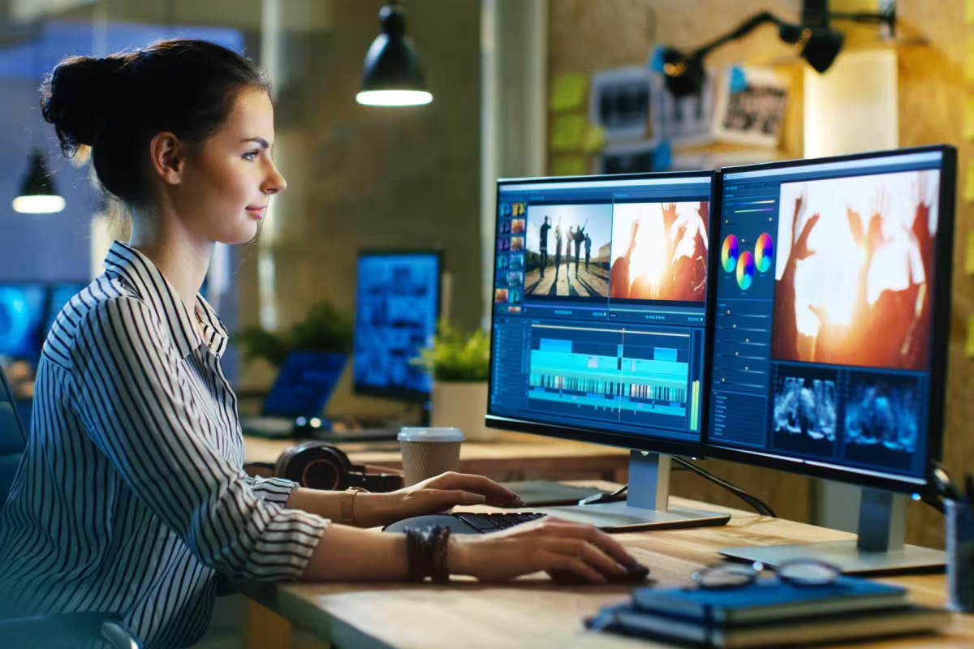

A video editor can add flow and rhythm to every piece. A freelance video editor supports smooth adjustments that help each scene come alive. Video editing services now offer flexible changes that support creative needs without stress. A video editing service brings gentle polishing that lifts every project.Modern content creation now embraces simple methods and calm styles. Freelance video production supports easy planning and clear actions. A freelancer cameraman understands diverse needs and captures scenes that feel relaxed and crisp. A freelance camera operator creates smooth results with steady care. A freelance videographer offers soft direction and helpful guidance for many setups. Videography blends sound and motion into balanced pieces that connect well. Videographers now give creators a wide range of choices. A video editor can shape ideas into neat forms. Video editing services keep content fresh and pleasing.Short forms of content often need gentle shaping. Freelance video production helps maintain a clean flow with steady progress. Videography supports fresh looks and encourages simple creative ideas.

A freelancer cameraman can adapt to fast changes and still deliver clear shots. A freelance videographer helps organise scenes that work for many uses. Videographers give careful attention to details that build warm visuals. A video editing service adds smooth transitions. A freelance video editor offers soft support that keeps projects moving. Video editing services help polish the final piece with friendly care. Creative fields continue to grow, and freelance video production supports this growth with ease. Videography remains flexible and offers many choices for different styles. A freelancer cameraman can capture scenes that hold interest. A freelance camera operator adds steady structure with soft handling. A videographer shapes each moment into a neat form. A freelance videographer supports varied ideas and simple plans. Videographers understand the value of clear visuals. A video editor forms smooth connections. A freelance video editor adds gentle adjustments. A video editing service keeps everything aligned. Video editing services complete the process with polished charm.

