Details About Mobile Massage Service

After a busy day, rest becomes essential for the mind and body. Choosing a calming massage in the evening can ease tension and help create peace. A mobile massage offers the ease of comfort without leaving your space. It brings a gentle environment where one can feel more settled. This type of massage supports better rest through soothing techniques. Booking a home massage therapist can improve the experience. It creates a calm setting and allows uninterrupted relaxation. People now prefer mobile massage booking due to its comfort and ease. It's an ideal way to let go of stress and unwind completely. A hotel room massage adds an extra layer of comfort during travel. It’s helpful for those needing quick relaxation without moving far. This method allows individuals to experience the best mobile massage while away. A hotel visit massage fits perfectly into busy schedules. It provides peace, calm, and a moment to recharge. If you are hunting for additional info on mobile massage london uk, view the above site.

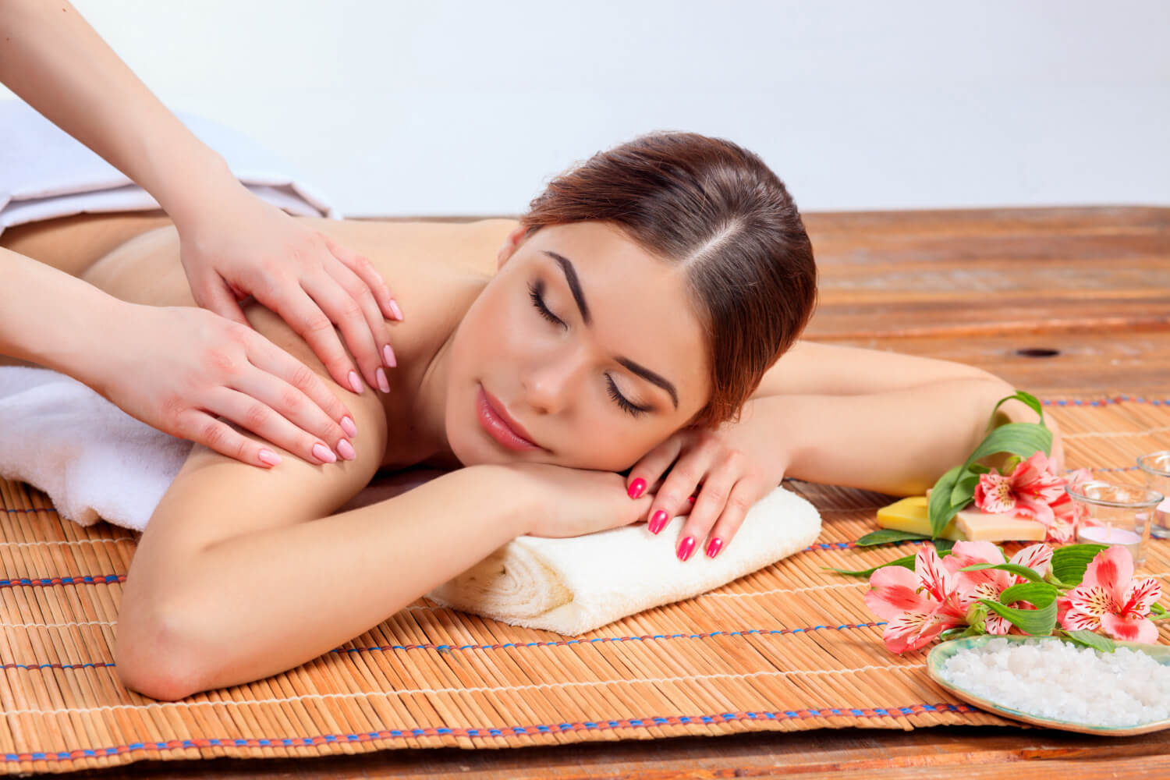

Choosing a mobile massage service is ideal for those who prefer flexibility. It works around your timing and comfort. With services like hotel visiting massage, relaxation becomes more personal. A massage in your room makes evenings feel peaceful and refreshing every time. Evening relaxation with massage improves sleep and restores calm. A mobile massage therapist understands how to work around your needs. They bring everything required to create a peaceful moment. It helps the body to feel lighter and more at ease. Using the best mobile massage option ensures a soothing and smooth session. A home massage therapist adds a familiar, peaceful touch. It's the comfort of home that makes it better. With mobile massage booking, you control the time and setting. The process becomes easy, calm, and fulfilling every single time. Resting after a long day means caring for the mind too. Gentle massage works beyond the body and calms thoughts. A hotel visit massage paired with peaceful sounds helps clear the mind. Choosing a mobile massage service removes the hassle of travel.

It saves time while bringing quality care. A massage at home lets you relax with your own routine. It’s more than physical comfort – it becomes a complete experience. With a mobile massage therapist, relaxation flows naturally. A hotel room massage becomes your personal retreat, allowing every muscle to loosen and the mind to settle. Evening massage creates space to rest, reflect, and feel whole. A mobile massage helps create that private, peaceful moment. Many now rely on home massage therapist services for daily balance. Choosing mobile massage booking takes only a moment. It brings comfort at the right time and place. Hotel visiting massage services allow restful nights while away from home. These services are about making wellness easy and accessible. Massage becomes more than touch – it's a way to reset. The best mobile massage sessions are designed for calm. Ending the day this way turns every night into a soothing escape.

