Deeper Look On Best Quality Adblue Emulators

Choosing the right AdBlue Emulator can make a big difference. It helps vehicles run smoothly and without trouble. Many look for solutions that are easy to use and work well. A good Emulator AdBlue system supports smooth functioning. It ensures the truck operates without interruption. People seek options that fit their needs and are dependable. A reliable Truck AdBlue Emulator gives confidence while driving. It also helps avoid delays and keeps the truck on the road. Picking the right tool is essential for peace of mind. It's wise to look for quality and value in one place. Make informed choices always. When thinking about an AdBlue Emulator Euro 6, look at compatibility. Not all devices match every truck type. An emulator for truck models should work without issues. Are you looking about emulator adblue? Browse the before described website.
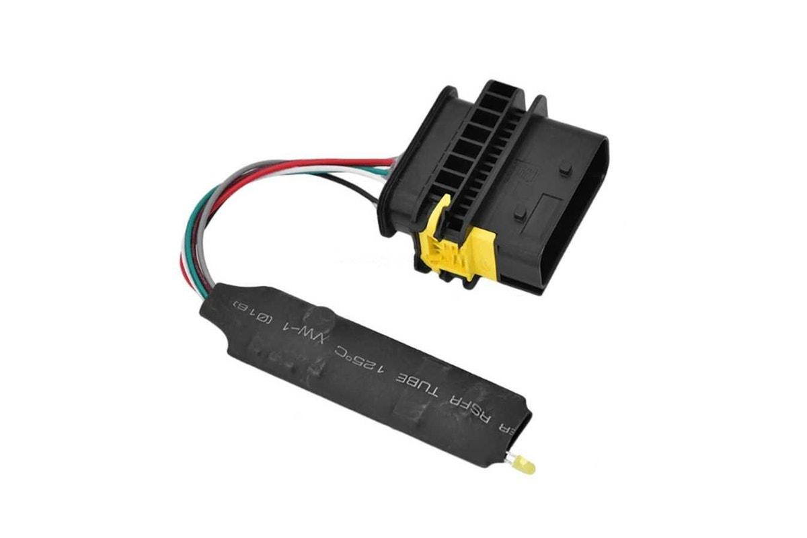
It should blend well with the vehicle's setup. Check for simple installation and user-friendly design. These make a difference when time matters. Ease of use helps save effort and confusion. Most drivers want something that works straight away. That’s why the correct emulator matters. A good fit means better performance. It also avoids unnecessary stops or issues on the road. Matching tools to the vehicle is always best. Durability is another factor people often consider. The best Emulator AdBlue choices last long and perform well. They must handle daily demands without failing. A trusted AdBlue Emulator should function in different conditions. Whether in hot or cold, it must deliver as expected. Truck drivers need dependable equipment that won’t disappoint. When a Truck AdBlue Emulator is strong, it works longer. It reduces the need for changes or repairs. That’s why quality builds are always preferred. Pick something known for lasting use. This saves money and keeps operations smooth every day. Support is also something to think about.

A good AdBlue Emulator comes with help when needed. Guidance during use adds value. It makes the experience easier and better. Even with a strong Emulator for Truck use, questions may arise. That’s why quick support and answers are important. People feel more confident when help is ready. Clear instructions and help improve trust. It also builds satisfaction among users. The right Truck AdBlue Emulator should not confuse anyone. Clear steps and assistance make a big difference in long use. Easy handling is always a win. Choosing an AdBlue Emulator should never be rushed. Look at all factors that make it work well. Find a balance of strength, ease, and reliability. Select the Emulator AdBlue that suits your vehicle needs. Focus on proven tools that serve you daily. With the right AdBlue Emulator Euro 6, performance improves. Less worry, more results. An emulator for truck systems should be simple and stress-free. Take time to review and compare. Good choices lead to better journeys. Think long-term and stay prepared. The best Truck AdBlue Emulator helps meet goals easily. Make the smart move for smoother driving always.

