A Few Facts About Work Family Ranch

Horse riding lessons offer far more than just a physical skill. They teach values that go beyond the riding arena. Riders learn patience, balance, and determination through every session. These lessons help shape emotional strength and mental calm. Equestrian lessons bring structure and rhythm into daily routines. Riders build trust, not only with the horse but also within themselves. As part of a family ranch, this experience becomes even more meaningful. The setting adds peace and connection. Many choose a work family ranch to deepen this bond. It becomes a journey of growth, learning, and emotional development in a natural space. Classes for horse riding are designed to fit all levels. From beginners to experienced riders, each lesson brings something new. Riders gain a better understanding of posture, communication, and control. If you are looking to learn more about work family ranch newville, visit the mentioned above site.

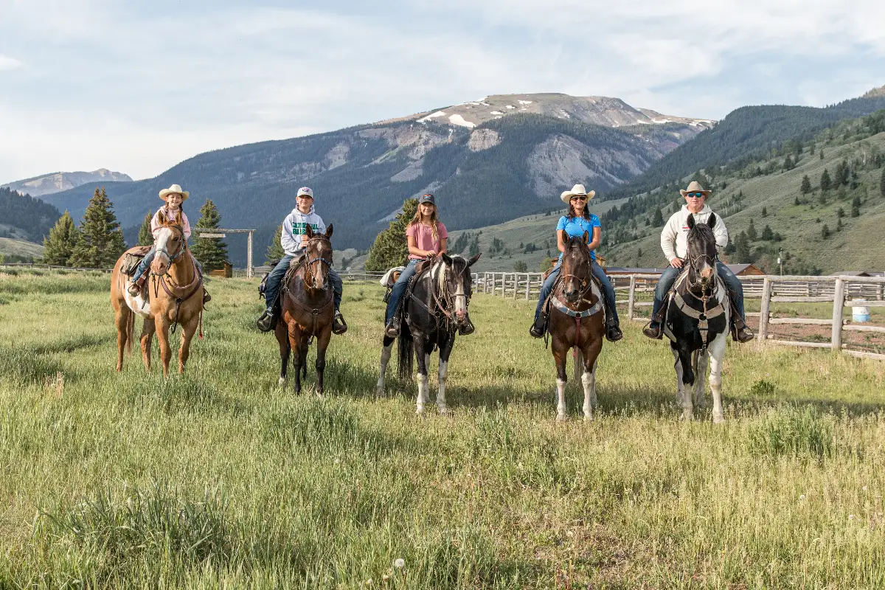

These skills improve focus and self-awareness. In a ranch setting, learning becomes more relaxed and enjoyable. A working ranch vacation often includes daily rides and lessons. This allows for real practice and improvement. Equestrian lessons are both fun and rewarding. They help build discipline without pressure. At a work family ranch, learning becomes a shared adventure. These experiences stay long after the holiday ends. A ranch environment enhances every lesson with open space and natural rhythm. Riders are not limited to short sessions. They ride freely, learn by doing, and grow at their own pace. Working ranch vacations create a strong bond between rider and horse. Horse riding lessons also teach care and responsibility. Taking part in feeding, grooming, and preparation builds confidence. Families can support each other during classes for horse riding. A family ranch offers encouragement, connection, and shared progress. This lifestyle brings people together through learning. It’s a balance of fun, challenge, and reward.

Horse stable boarding plays a key role in this lifestyle. Ranches with boarding stables for horses teach guests how to care for animals. These experiences support growth in empathy and responsibility. Equine boarding facilities ensure horses are well-kept and healthy. Ranch visitors often take part in stable routines. This daily involvement builds discipline and awareness. At a work family ranch, every task feels like part of the adventure. Children and adults both benefit from hands-on learning. Horse stable boarding is not just about shelter—it’s about full-time care and understanding. These lessons are practical and lasting. The full ranch experience leaves a lasting impact. A family ranch offers much more than a stay—it shapes values. Horse riding lessons become lessons for life. Riders grow emotionally, mentally, and socially. Equestrian lessons help build discipline, confidence, and joy. Classes for horse riding blend structure with freedom. Equine boarding facilities teach respect for animals and nature. Boarding stables for horses allow families to be hands-on. A working ranch vacation brings purpose and enjoyment together. From saddling up to stable duties, each moment teaches something new. A work family ranch truly shapes life beyond the saddle.

