Individual Guide On Voice Over Agents

A voiceover can truly elevate any narrative, adding depth and emotion to the story. Whether it's for an advertisement, documentary, or animated film, a well-placed voice can bring characters and scenes to life. A voice over artist can transform written words into powerful messages, enhancing the listener's connection to the content. The right voice adds warmth, personality, and clarity to a story, making it more engaging. Choosing the right voiceover is crucial, and working with the right voice over agency ensures that the tone, style, and delivery align with the project’s goals. Voice over can create atmosphere and set the pace of a narrative. For example, a calm, soothing voice can enhance a peaceful, reflective scene, while a lively, energetic voice might energise a fast-paced commercial. Are you looking about london voice over agency? Check out the earlier discussed website.

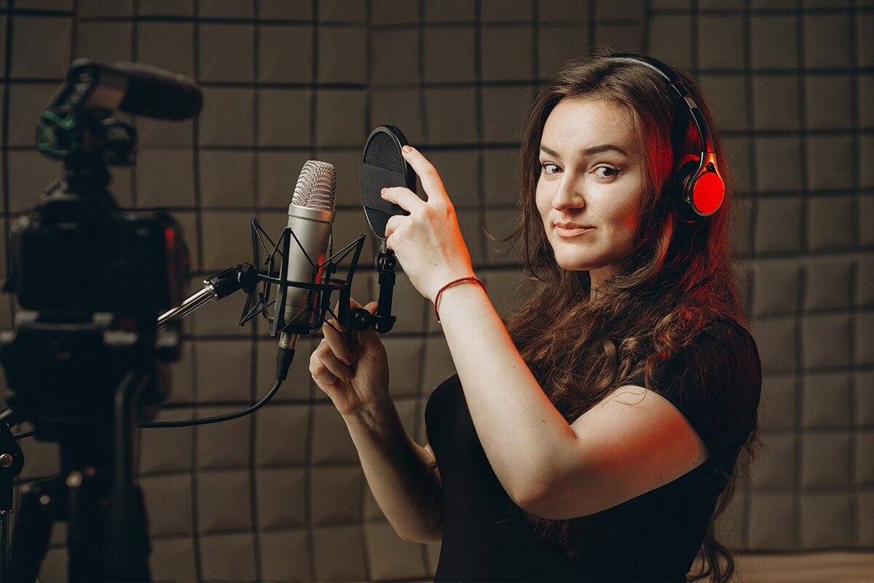

The choice of voice is vital in conveying the intended emotion, and voiceover agencies often offer a range of artists with different styles and capabilities. When hiring a voiceover artist agency, it’s important to consider the specific requirements of your project. A professional voiceover agency can help guide you in selecting the right voice over agent for your needs, ensuring a perfect match for your project. When searching for the right voiceover talent, it’s essential to find someone who fits the tone and style you need. Different projects require different voices, and the best voice over agencies will help you narrow down your options. Whether you need a deep, authoritative voice or a light, conversational one, voiceover agents can provide a variety of choices. Voiceover agencies have extensive databases of professional artists, making it easier to find the ideal voice. This flexibility allows you to discover the perfect voice that will complement your content, whether it’s for a film, advertisement, or corporate project.

Using voice over for a project requires careful attention to detail. A voice over artist agency can help in selecting the most suitable artist who can deliver the script convincingly. The tone, pitch, and delivery style of a voice can change the perception of a piece entirely. By working with voiceover agencies, you ensure that every aspect of the narration is in expert hands. From the initial casting to the final recording, a good agency offers professional guidance and ensures the voiceover aligns with the vision of the project. This level of expertise guarantees a top-quality final product. Whether working on an animation, commercial, or e-learning module, voice over is an invaluable tool. The right voiceover can enhance the narrative, making the content more compelling and memorable. By partnering with the best voice over agencies, you gain access to professional artists who can bring your story to life. From selecting the voiceover artist to overseeing the recording process, the support of a voiceover agency ensures that every project sounds as great as it looks. Effective use of voice over can truly transform a good project into a great one, creating a lasting impression on your audience.

