Detailed Look On Wedding Locations

Finding the right place for a big event takes time and thought. Whether it's a wedding, party, or business gathering, the right setting makes a big difference. Many people search for the ideal wedding venue or conference venues that suit their style and needs. Wedding locations can vary from grand wedding halls to more casual spaces. It's also helpful to explore pubs near the venue for added convenience. Some may prefer a quiet pub for small gatherings. Choosing a place with proper amenities and flexible options helps ensure the event flows smoothly without interruptions or last-minute problems. It’s smart to compare different conference centres or wedding halls before making a final choice. Look at the size, layout, and accessibility. For example, a spacious conference room can host presentations and discussions comfortably. Visit the below mentioned website, if you're looking for more information regarding wedding locations hertfordshire.

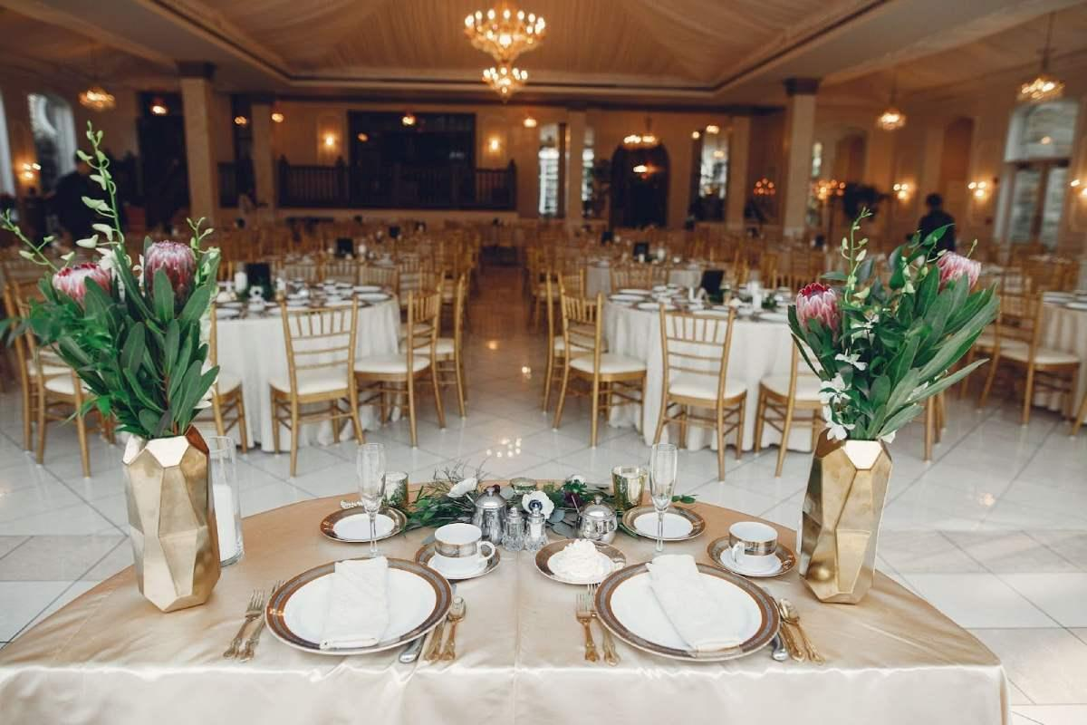

Similarly, a charming wedding venue sets the right mood for a joyful celebration. Many wedding locations now offer extra services, adding value. Don’t forget nearby pubs for guests to relax after the event. For corporate events, a modern meeting room can provide a professional setting. Think about your guest list, activities planned, and time of day when picking the venue. The theme and tone of your event should match the setting. A classic wedding may need elegant wedding halls, while a relaxed one might suit a cosy pub. The same idea works for work functions—conference facilities should support the purpose. A team meeting may only need a small meeting room, but conferences might need full conference centres. Locations with conference rooms offer the space and tools needed for smooth sessions. Choose places that let your event shine and help your plans go well. A matching atmosphere makes every gathering better and more memorable. Convenience matters just as much as looks or size. Easy parking, good access, and nearby pubs are bonuses.

Pubs near the venue make it easy for guests to socialise. Event planners often book conference venues that offer support and comfort. Modern conference facilities may have everything from catering to presentation screens. A well-maintained conference room adds ease and efficiency. When it comes to weddings, the wedding venue must fit the couple’s vision. Wedding locations with nearby pubs also keep guests entertained. A thoughtful venue choice brings comfort, joy, and style together in one space. Booking early saves time and avoids unwanted stress. Popular wedding halls and conference centres fill up fast. Start the search early to get more options. Make a checklist that includes must-haves like a conference room or meeting room, or nearby pubs. Visit several wedding locations to see what feels right. Wedding venue styles vary, so it's important to explore. Don’t overlook casual places like a quiet pub. With careful planning, finding the perfect place becomes easier. Whether for business or celebration, venues should bring comfort, connection, and charm. A good venue sets the scene for a great experience.

