Benefits Of Freelance Videographers

Videos have become a strong way to promote products, services, and ideas. They grab attention faster than text or images. Viewers often stay longer on pages with videos. Businesses use a videographer to create engaging clips that boost interest. A short, well-made video can deliver messages clearly. Freelance videographers offer flexible solutions for brands of all sizes. With simple planning, even one freelance videographer can create amazing results. Videos are used everywhere—from websites to social media. This makes them a key part of any strategy. The demand for videography continues to grow across many industries. Viewers enjoy visuals that feel natural and direct. Using a video makes information easy to understand. It breaks down complex ideas in seconds. A good freelancer cameraman captures the right moments to highlight the message. Freelance videographers know how to present ideas in a simple way. Visit the below mentioned website, if you're looking for more information regarding freelance videographers.

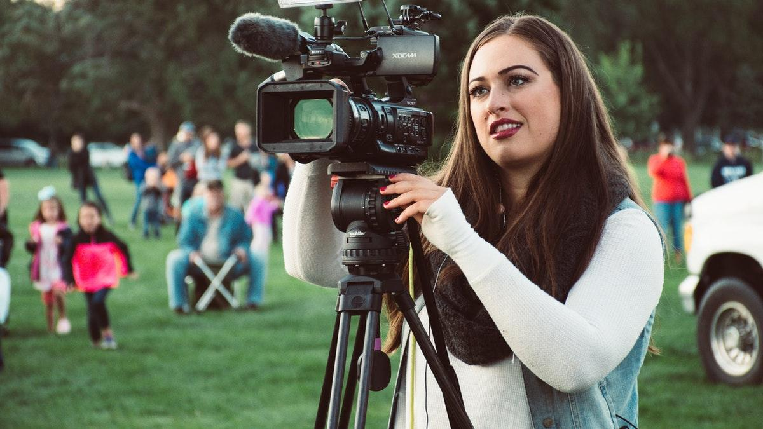

These short clips can be shared easily across platforms. Audiences connect better with videos than with plain text. Many businesses hire videographers to keep their message clear. Freelance videographer services are ideal for promotional needs. Simple visuals and strong messages work well together. This approach helps to boost reach, engagement, and viewer interest. Clear storytelling through videography builds better audience trust. Visuals play a major role in making content stand out. A skilled videographer knows how to create a balance of sound, images, and flow. Freelance videographers work with brands to make videos that feel authentic. Their creativity helps shape the overall appeal. Freelance videographer talent adds originality to every project. A good freelancer cameraman understands how to bring an idea to life. Videography can be used to show value in products or services. Videos spark interest and encourage action. They are great for brand recall and user engagement. With smart planning, videographers create content that works across many platforms. Freelancers are now a popular choice for video production. A freelancer cameraman works flexibly and provides customised services.

This allows businesses to stay within their budget. Hiring freelance videographers means working with skilled creators without extra costs. They bring fresh ideas to every project. A freelance videographer can adapt to various styles. This makes them a smart option for different needs. Videographers with freelancing experience often deliver faster results. They handle projects with care and creativity. Their input helps shape promotional efforts effectively. Freelance videographers are known for their dedication and versatility in content creation. Videos deliver messages faster and in a more appealing format. People respond better to visuals than written content. With help from videographers, messages become more engaging. Freelance videographers offer flexible services suitable for any promotion. A freelancer cameraman works with purpose to achieve results. Videography improves how people see a brand. A freelance videographer knows how to guide ideas into final content. Their work helps create emotional connections. Promotional videos support campaigns and attract attention. When created by experienced videographers, videos leave lasting impressions. Clear, simple content shared through video builds stronger awareness and trust.

