An Overview Of Videography Companies

Finding the right video production company can make a big difference. It helps turn simple ideas into strong visual stories. A reliable videography agency understands what works best for different styles and goals. Whether it’s a product shoot or a service showcase, working with a professional videographer makes every detail count. Many businesses also look for a trusted videographer agency to ensure quality at every step. These teams handle every part smoothly. They help in shaping concepts, filming, and editing. A skilled video production company adds value by creating content that feels natural, polished, and ready for any platform or purpose. Choosing a corporate video production company means picking a team that knows how to speak for your business. The right choice will reflect your message clearly. A strong corporate video production agency builds videos that connect with your audience. Are you looking about videography companies london? Check out the before talked about site.

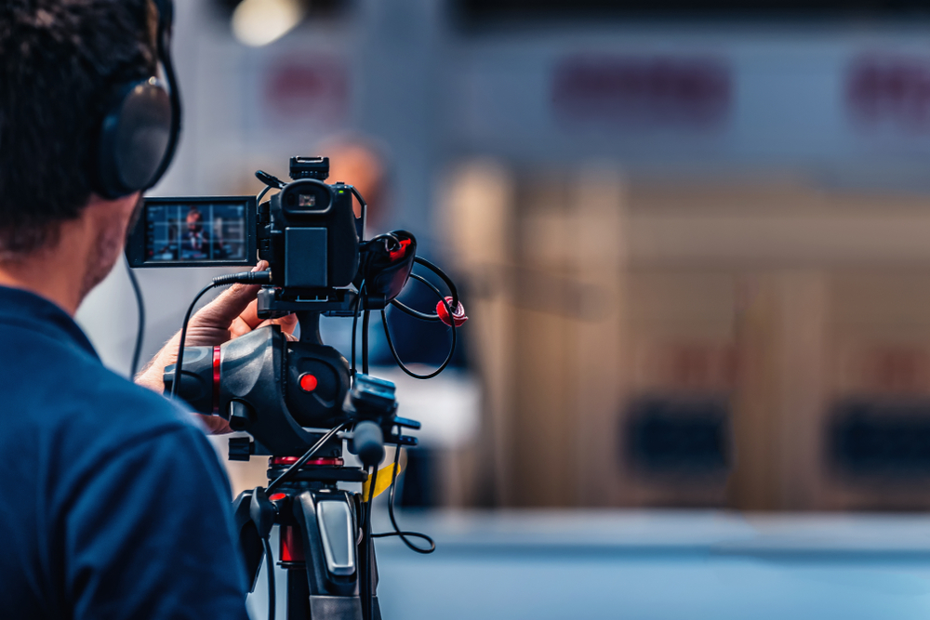

They help set the tone and keep things engaging. Different corporate video production companies offer a variety of approaches. Some may focus on simplicity while others add creativity. Always look for those that offer balance. That ensures professionalism with an artistic touch. A talented corporate videographer helps shape the entire vision without missing key moments or emotions. A good video production partner keeps everything simple and smooth. They listen, guide, and deliver on time. Quality always stands out when working with an experienced team. Many turn to a videography agency when they want a range of services under one roof. Whether short clips or full-length stories, a skilled videographer knows how to present them effectively. A dedicated videographer agency supports different needs across industries. They tailor each project to suit goals and values. From planning to final editing, everything should flow with ease and purpose, offering an impressive visual output every time. Corporate video production company experts bring more than just filming skills. They help express brand identity through sharp visuals and thoughtful messaging.

A dependable corporate video production agency understands branding, tone, and target viewers. That makes every video meaningful and purposeful. Among corporate video production companies, look for those with a strong eye for detail. A creative corporate videographer highlights strengths in simple yet effective ways. Many also support brand video production, combining strategy with style. Their goal is to represent the brand in its best light. This creates stronger awareness, more engagement, and clearer communication across various platforms. Brand video production continues to rise in popularity across many industries. It helps build recognition and trust. A strong video production company will understand how to shape content that feels natural yet impressive. From idea to screen, a good videography agency supports each step. With a talented videographer involved, results stay polished and on-point. Hiring a capable videographer agency brings a wider scope of ideas. Corporate video production companies take time to understand audience needs. They aim for clarity, connection, and creativity. When everything comes together, the final video leaves a lasting impression. That’s the mark of a professional video production team.

