A Summary Of Cheese Hamper Delivery

Finding the perfect gift can be stressful, especially at the last minute. Online platforms make it easy to select hamper presents that suit any occasion. Gift hampers come in a variety of options, from luxury gin hampers to picnic hampers, catering to different tastes. A gin gift hamper is ideal for celebrations, while gin hampers provide a sophisticated touch. Picnic hampers, including wicker picnic hamper styles, are perfect for outdoor gatherings. Picnic hampers for two add a personal and romantic touch. British cheese hamper selections are popular for food lovers. Cheese hamper delivery ensures gifts arrive quickly and safely. Cheese hamper gifts are a wonderful way to impress friends and family. They are thoughtfully curated with high-quality cheeses and accompaniments. you're searching for more information about hamper presents uk.

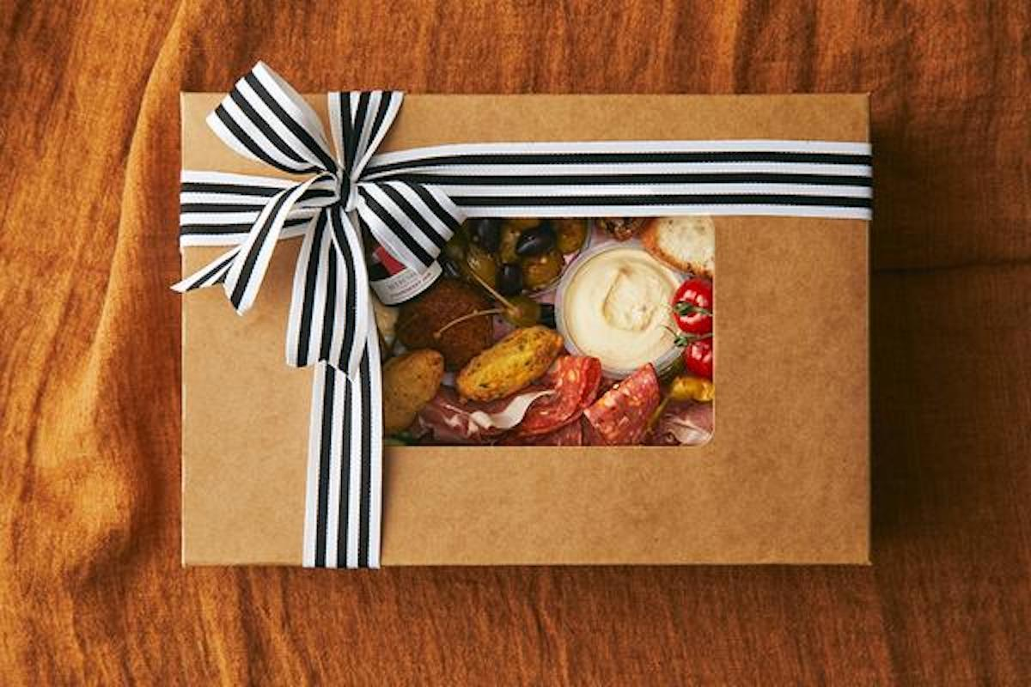

Afternoon tea hampers offer another elegant option, combining sweet and savoury treats. Send afternoon tea hamper services ensure that recipients enjoy a fresh, delightful experience. Afternoon tea hampers for delivery are perfect for remote gifting. Luxury gin hampers are increasingly popular for those who enjoy fine drinks. Gin hampers and gin gift hamper collections make celebrations special. Wicker picnic hamper sets are practical and visually appealing. Picnic hampers for two are excellent for couples or intimate gatherings. Online platforms provide fast delivery for those last-minute gifting needs. Gift hampers and hamper presents can be ordered and delivered quickly. Cheese hamper delivery ensures quality and freshness even at short notice. Afternoon tea hampers for delivery are easy to arrange with a few clicks. Gin hampers or gin gift hamper options are available for speedy shipping. Picnic hampers, including wicker picnic hamper sets, can be delivered directly to doors. Luxury gin hampers are carefully packaged to maintain elegance during transit. The convenience of online ordering saves time and ensures recipients receive thoughtful, high-quality gifts promptly and reliably. This means there is no need to worry about shopping for gifts and packaging. Variety in hamper presents allows for creative and personalised gifting. Gift hampers can be themed around food, drinks, or special occasions.

Afternoon tea hampers are perfect for relaxed, elegant celebrations. Send afternoon tea hamper services offer convenience and charm. British cheese hamper options cater to gourmet tastes. Cheese hamper gift selections include accompaniments for a complete experience. Picnic hampers and picnic hampers for two bring joy to outdoor settings. Gin hampers and gin gift hamper collections make memorable presents. Wicker picnic hamper sets add style and practicality. Luxury gin hampers provide indulgence, making every occasion feel special and thoughtful. Choosing the right hamper presents is simple with online options. Gift hampers can include afternoon tea hamper, cheese hamper gift, or gin gift hamper selections. Send afternoon tea hamper or afternoon tea hampers for delivery ensures convenience. Picnic hampers, wicker picnic hamper, and picnic hampers for two create charming experiences. British cheese hamper and cheese hamper delivery satisfy gourmet preferences. Gin hampers and luxury gin hampers add sophistication to celebrations. Overall, online platforms make last-minute gifting stress-free and enjoyable. The variety of hamper presents ensures every recipient feels valued, loved, and delighted with thoughtful and carefully curated gifts.

