Gynecomastia Clinic - An Introduction

Gynecomastia is a condition that affects many men, causing enlarged breast tissue. It occurs when there is an imbalance of hormones, leading to excess breast tissue. One of the most common reasons for this is hormonal changes during puberty. However, it can also be caused by factors such as genetics, obesity, or the use of certain medications. A gynecomastia clinic often offers treatments that address the root cause of the condition. In many cases, gynecomastia reduction surgery, including gyno gland removal, is recommended to eliminate the excess tissue and restore a more natural chest contour. Hormonal imbalances are a significant contributor to gynecomastia. These imbalances cause an increase in estrogen levels or a decrease in testosterone. This can lead to the growth of glandular breast tissue in men. In some cases, the condition resolves on its own over time. However, many individuals seek treatment at a gynecomastia clinic for lasting results. Are you looking for a gynecomastia clinic? View the before talked about site.

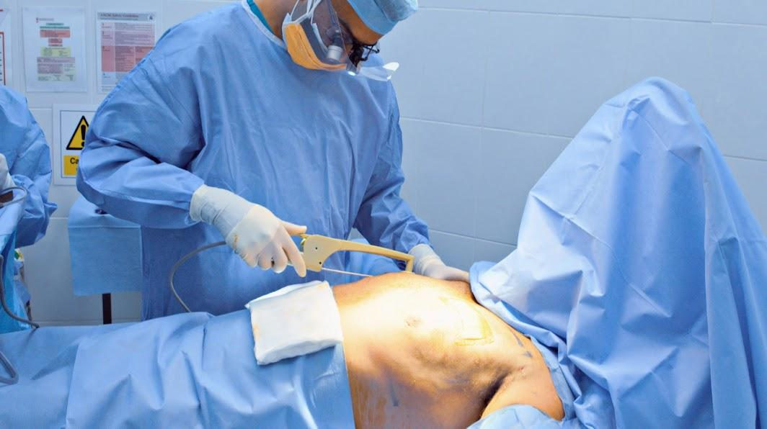

A gynecomastia doctor may recommend gynecomastia gland removal surgery to eliminate the excess tissue. This procedure helps to restore a flatter, more masculine chest shape and address any discomfort or self-consciousness associated with the condition. Obesity is another common factor that can lead to gynecomastia. When men gain excess weight, they may develop fatty tissue in the breast area. While this isn’t the same as true gynecomastia, it can mimic the appearance of enlarged breasts. In these cases, gynecomastia reduction surgery is often considered. A gyno surgeon will assess the individual’s condition and determine the best approach, which may include a combination of liposuction and gland removal. With gynecomastia removal, patients can regain their confidence and enjoy a more sculpted chest, improving both their physical appearance and emotional well-being. For those seeking treatment, finding the best gyno surgeon is crucial. A skilled and experienced gyno surgeon will ensure that the procedure is done safely and effectively.

When choosing a gynecomastia clinic, it’s important to look for one with a strong track record of success. A gynecomastia doctor will provide an in-depth consultation, explain the procedure, and discuss potential outcomes. Whether undergoing gyno gland removal or another method of treatment, the right surgeon can help achieve the desired results. This professional guidance ensures that the patient receives the most appropriate care for their unique condition. After surgery, many individuals experience a significant boost in confidence and self-esteem. The physical transformation following gynecomastia removal often leads to a more positive body image. For many, the psychological benefits of the procedure are just as important as the physical ones. A gynecomastia clinic not only provides surgical expertise but also offers ongoing support. With proper aftercare, patients can heal and achieve the best possible results. Gynecomastia reduction surgery is a life-changing treatment that improves both appearance and quality of life, helping men feel more comfortable in their bodies and confident in their everyday activities.

