Great Things About Website Design

Navigating a site should feel natural. Visitors expect a smooth experience. Every click should make sense. A clear layout helps people find what they need. Buttons must be easy to spot. The overall website design plays a huge role. A confusing site layout drives users away. Simple choices make a big difference. Smooth interaction matters just as much as style. If people can’t use it, they’ll leave. That’s why user-friendliness is key. It keeps visitors engaged and coming back. Many businesses rely on experts for this reason. A professional web design agency understands these expectations very well. Website design needs to feel intuitive. People shouldn’t have to think too hard. Easy navigation encourages users to stay longer. A good structure leads users naturally. They don’t feel lost or stuck. Web development often focuses on this structure. A skilled web developer builds smooth paths. If you are searching for additional details on website design staffordshire, browse the above website.

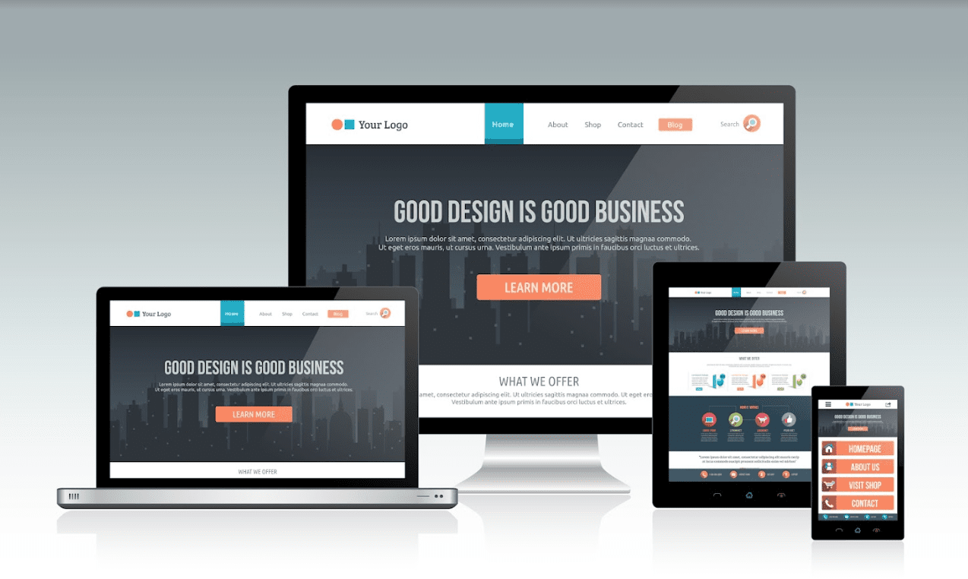

Every part should work as expected. When done well, visitors enjoy their time. That makes them more likely to take action. They might shop, contact, or subscribe. This ease helps businesses grow. That’s why web design companies highlight user-centred layouts. Clarity and comfort create results. Colour schemes matter. Fonts matter. Every visual piece shapes user experience. Website design agencies know this well. They consider contrast and size. These choices support readability. Even whitespace makes an impact. If things feel too crowded, people leave. A web design company will space things right. Everything should feel easy on the eyes. It’s not just about looking nice. Functionality matters just as much. Quick load times, responsive features, and clear layouts help. These traits make the experience enjoyable. When people enjoy browsing, they stay longer. Longer visits increase engagement and trust. Usability influences every decision made. Web design is more than style. It’s about how everything connects.

It’s how fast things load. It’s how users get from one page to the next. A professional web developer focuses on this flow. They test and adjust as needed. Feedback helps fix hidden problems. Web design companies know how important testing is. They solve issues before visitors notice. Every improvement boosts usability. This builds a site that really works. Visitors notice when things run smoothly. That’s what encourages them to return. Good web design keeps improving. Styles and expectations evolve over time. That’s why many rely on a web design agency. These experts understand the value of updates. They track what’s working and what’s not. Website design needs maintenance like anything else. With regular improvements, sites stay modern. The website design agency ensures updates fit brand goals. Small changes can have big results. When websites stay friendly and fresh, people stay engaged. That’s how a simple interface builds stronger business connections. Web development is ongoing for this reason. Success comes from always refining the experience.

