Details On Shatterproof Mirror

Safety is a priority in every space, whether work-related or public. A shatterproof mirror offers peace of mind in these places. It reduces risks while maintaining style. Many use an unbreakable mirror in fitness areas and schools. These mirrors are strong and dependable. A non breakable mirror helps avoid accidents and injuries. It is ideal where safety comes first. The acrylic mirror is widely used due to its tough surface. Unlike regular glass, it resists impact. A large acrylic mirror can be installed in open areas. It gives both function and protection without compromise. Every material has a role in secure environments. An acrylic mirror sheet is flexible and durable. This makes it easy to use in different spaces. A large perspex mirror gives wide visibility. It suits gyms, dance studios, and public buildings. A perspex mirror keeps spaces safe while adding value. Browse the following site, if you're looking for more details on shatterproof mirror.

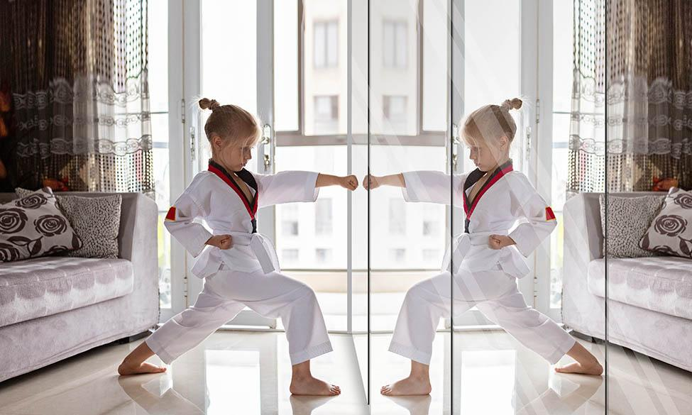

Safety mirrors are used for more than one purpose. Perspex gym mirrors enhance exercise rooms while remaining strong. A full length perspex mirror is often used in changing areas. It adds both safety and practicality. These types of mirrors provide long-lasting use. They are trusted in many settings. Different mirror options fit various room sizes and purposes. A plexi mirror sheet is often chosen for high-traffic areas. It is light and safe to handle. A plexiglass mirror cut to size offers great flexibility. It fits specific needs in any space. This reduces waste and maximises coverage. An acrylic plexiglass mirror is ideal for wall panels. It supports safety in places that need extra care. Schools, offices, and public spaces all benefit. These mirrors are clear, lightweight, and reliable. Their surfaces are resistant to breakage. That makes them a smart, practical choice for many. Designing a professional or shared space needs thoughtful planning. Safety must always be part of the design.

A shatterproof mirror works well in open-plan areas. It combines reflection and reliability. An unbreakable mirror is good for child-friendly zones. There’s less concern about cracks or shards. A non breakable mirror helps avoid daily wear and tear. The acrylic mirror is also perfect for creative layouts. It can be used in displays or wide walls. A large acrylic mirror suits public washrooms and reception areas. It gives a sense of openness while being secure. Safe environments support comfort and peace of mind. An acrylic mirror sheet provides those benefits. A large perspex mirror ensures a wide viewing angle. The perspex mirror fits neatly into modern interiors. Perspex gym mirrors are useful and long-lasting. A full length perspex mirror can be placed in personal spaces too. A plexi mirror sheet adds light and depth to rooms. A plexiglass mirror cut to size saves time and effort. The acrylic plexiglass mirror is a top pick for safety. It reflects clearly and resists damage. Choosing these mirrors makes every space smarter and safer.

