The Value Of Smart Hands Services

Onsite support plays a key role in maintaining smooth operations. When technical systems stop working, it can affect everyday work. That’s why direct assistance becomes essential. For businesses using IT hardware, any delay in fixing problems can lead to longer downtimes. Quick attention helps restore stability faster. Teams managing business IT hardware often need someone onsite to check and resolve issues immediately. This kind of support reduces interruptions. It's helpful when problems are urgent. Having experts physically present can solve matters quickly. It supports better efficiency. Many choose onsite help to keep systems running without long waits or confusion. Problems with enterprise hardware can happen at any time. When issues arise, remote help may not always be enough. Sometimes, the situation needs an onsite specialist. Hardware deployment often involves many devices and parts. Any small error can impact the full setup. Fixing it properly requires direct handling. Are you hunting about smart hands services? Go to the before talked about site.

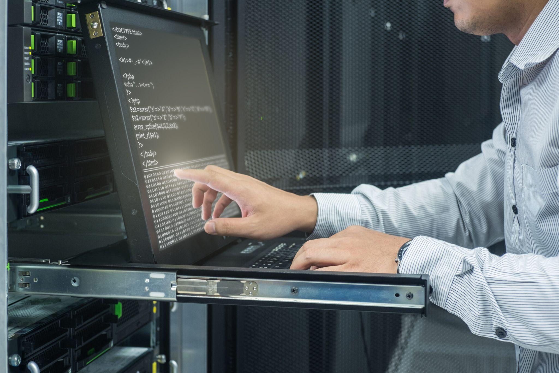

In some cases, IT infrastructure deployment cannot continue until a fault is corrected. This is where onsite professionals are valuable. They bring tools and knowledge to the spot. It ensures that systems are up and working again soon. Direct support offers real-time answers. It helps keep businesses productive and steady. Network infrastructure deployment involves many devices and steps. If any part goes wrong, it can affect the rest. Onsite support is useful in finding and fixing such problems. Fast response helps avoid delays. Smart hands services are a popular way to manage this. These services provide on-ground assistance whenever needed. They’re useful during urgent tasks. They help to complete processes without delay. Smart hands IT services add extra value. They support tasks that need physical presence. Experts perform checks, make changes, or replace faulty parts quickly. This helps maintain performance and prevent disruptions in the overall flow. Many rely on IT smart hands when physical tasks need expert handling. These specialists help during complex processes. Smart hands support is practical when unexpected issues arise.

They follow clear instructions and offer help directly. Onsite assistance helps reduce pressure on internal teams. Businesses feel confident knowing expert help is nearby. It becomes easier to manage large-scale activities. Even when dealing with EOL IT services, onsite support ensures everything is removed or replaced safely. This helps avoid any mix-ups. It also allows businesses to focus on other tasks. Support that is available in person adds real value. Choosing onsite help boosts productivity and ensures a smoother experience. It brings peace of mind during busy times. Whether it’s for IT hardware or during a major hardware deployment, direct support proves helpful. It makes IT infrastructure deployment more reliable and fast. When enterprise hardware breaks down, quick action matters. Smart hands services offer timely solutions. They are trained to help with precision. Businesses benefit from using smart hands IT services. They help complete tasks faster. EOL IT services are easier to handle with this support. It ensures things get fixed with care. Onsite help remains an important choice for many.

