The Value Of Fire Compartmentation Services

Fire safety is no longer a one-time task. It’s ongoing. Future-proofing your building means taking proactive steps. Focus on systems that reduce damage before it starts. Fire compartmentation services are the foundation. They divide a building into safer zones. These zones slow fire and smoke spread. Fire compartmentation creates time for safe escape. It also helps emergency teams respond quickly. These systems are not decorative—they’re lifesaving. Planning now avoids chaos later. Fire safety requires both knowledge and action. Every detail matters, even the parts you can’t see. Fire compartmentation contractors help future-proof buildings effectively. They understand the best methods for protection. Fire compartmentation works vary between buildings, so expert guidance helps. These professionals review layouts, install fire barriers, and test them. Fire compartmentation must follow regulations. Without it, fire can spread unchecked. If you are seeking to learn more about fire compartmentation services, visit the mentioned above site.

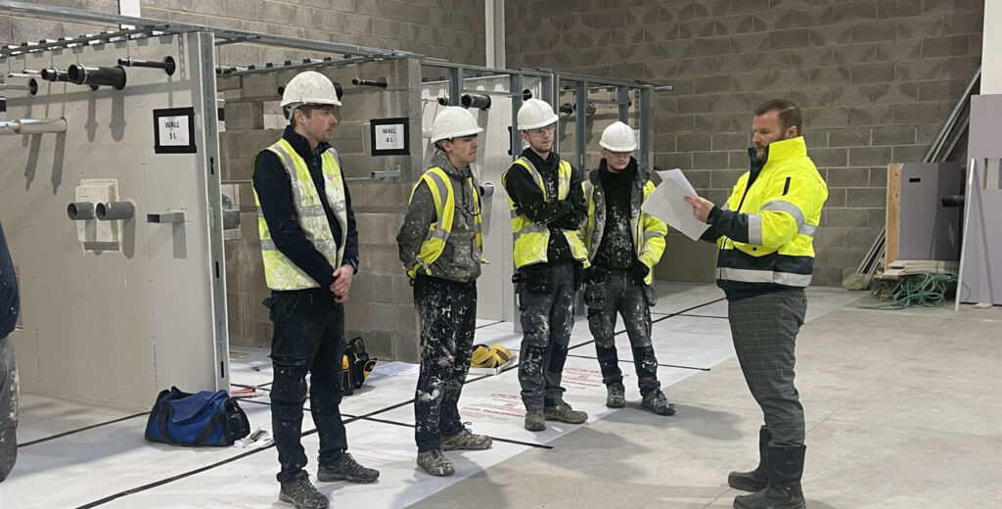

That's dangerous and costly. Regular reviews help identify risks early. Contractors ensure materials are strong and installed right. No guesswork involved. This precision creates long-term protection. A safe building is a lasting investment. Think long term when planning upgrades. It pays off in safety and security. A strong line of defence is the fire door. A fire door installer ensures it fits and seals well. Proper fire door installation stops smoke from leaking through gaps. It also keeps heat at bay for longer. Fire door installation companies offer expert fitting and certified doors. These are tested for reliability under pressure. Poorly installed doors may look fine but won’t protect you. Choose professionals who follow standards strictly. Every fire door needs a regular check. Don’t wait until it fails during an emergency.

Stay prepared and stay safe. Fire stopping systems complete the picture. These systems seal hidden gaps in ceilings or walls. Fires often spread through these unseen spaces. Fire stopping installation prevents that from happening. A certified fire stopping contractor understands where problems start. They know which materials perform best in heat. Fire stopping installers are trained to catch small issues early. These systems aren’t always visible—but their impact is huge. Together with fire doors and compartmentation, they build a safer environment. Fire risks don’t announce themselves. These systems help stop danger before it grows. Future-proofing a building means thinking ahead. Don’t wait for an incident to take action. Fire compartmentation services and expert fire stopping systems are essential. Hire professional fire compartmentation contractors for lasting protection. Choose reliable fire door installation companies that know their craft. Fire door installers ensure doors do more than just close. They protect. Fire stopping installers seal the smallest gaps that could cause the biggest problems. Safety isn’t just a feature—it’s a foundation. Build it strong from the start. Your future self will thank you.

