Facts On Funeral Director

A funeral home is a trusted partner during one of life’s most emotional times. It provides professional support and reliable guidance when it is needed most. Funeral homes work with families to ease the stress of saying goodbye. They offer clear, calm advice and help with decisions. From planning the order of service to arranging transportation, their experience ensures nothing is overlooked. Practical details are handled with care, letting families focus on remembering their loved one. Funeral homes offer a calm space, where every detail can be managed and questions answered. A funeral director is often the main point of contact for these arrangements. They handle paperwork, schedule services, and coordinate with local authorities. Their role includes advising on choices, from burial to cremation. In addition to the formal tasks, funeral directors provide comfort and reassurance. Browse the following site, if you are searching for more details about funeral director west wickham.

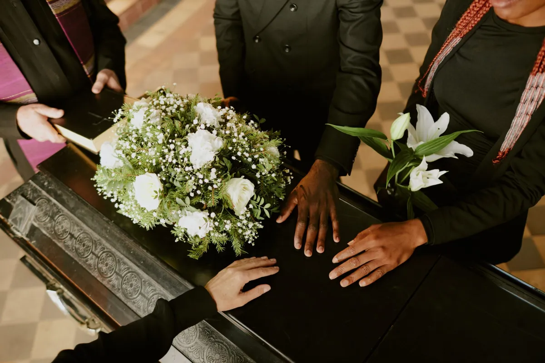

They know how to guide a family through unfamiliar steps. By listening closely and offering gentle suggestions, they ensure the funeral reflects the wishes of the deceased and the family. This level of service is what makes funeral homes trusted throughout generations. Undertakers work quietly behind the scenes to prepare the deceased with respect and care. Their work goes beyond the practical—they ensure dignity and peace for the departed. Undertakers also support families by helping them understand what happens next. They explain what to expect and help with choices like flowers, music, and readings. These professionals understand that grief affects everyone differently. They create an environment where questions are welcomed and where no request is too small. The support they offer helps families focus on memories, not logistics. For many, cremation has become a thoughtful and practical choice. Cremation services can be tailored to meet different needs and wishes.

Whether it is a private family farewell or a larger memorial service, cremation offers flexibility. Direct cremation is a simple, no-service option that is increasingly popular. Families who choose direct cremation appreciate its simplicity and lower cost. While there is no ceremony at the crematorium, a private gathering or memorial service can be held elsewhere. These choices offer a chance for remembrance that suits the family’s needs. When choosing a funeral home or cremation service, it helps to talk with funeral directors and ask questions. They will explain every step and help families feel confident in their decisions. Whether it’s a traditional funeral or a direct cremation, having a caring professional to turn to makes all the difference. Funeral homes, funeral directors, and undertakers offer more than a service—they provide comfort, experience, and reassurance. They help families say farewell with respect, care, and dignity. Their quiet presence and expert support make a very difficult time feel a little easier. Their support brings a sense of calm and clarity during these difficult times.

