Event Furniture Hire - Things To Learn

There’s a certain charm in transforming an ordinary space into something memorable. Adding the right touches can shift a plain event into a magical celebration. That’s why thoughtful styling plays a big role in creating the perfect setting. Choosing the right wedding decor hire can instantly elevate the mood. It offers a range of options to create elegance or playfulness. From soft lighting to floral accents, everything helps to shape the atmosphere. Carefully selected elements turn ideas into experiences. Guests notice every detail. A well-decorated space speaks louder than words. It sets the tone before the celebration begins. When planning a special occasion, each detail holds significance. Even small items contribute to the overall effect. Using wedding prop hire can bring themes to life with ease. Props like arches, signs, and display pieces add character. These items create moments worth capturing. They work well for both modern and vintage styles. Are you searching for table hire sussex? Look at the before mentioned website.

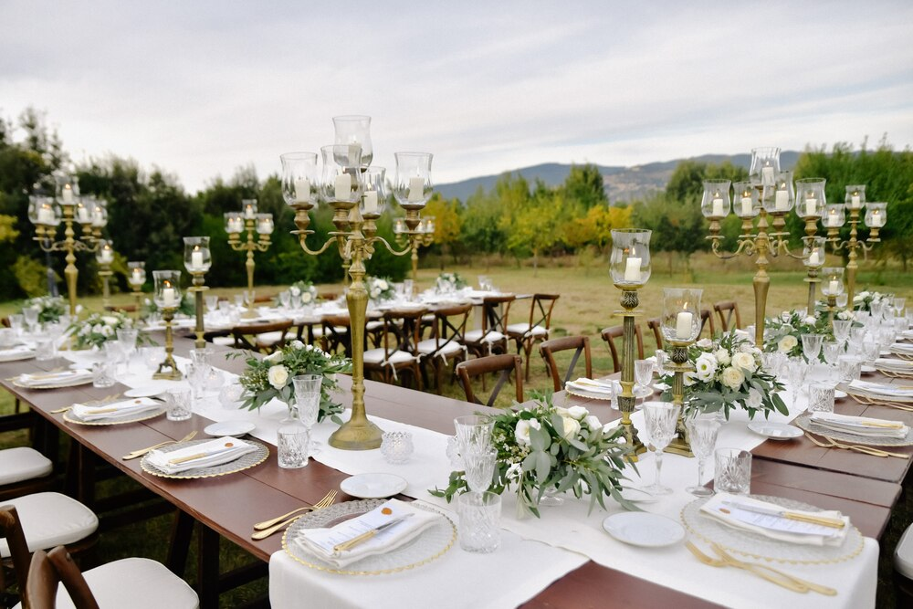

Whether the aim is elegance or fun, props support the mood. They’re versatile and easy to include. Decorating with props allows endless possibilities. With the right choices, the entire event gains a unique flair. Props help guests remember the occasion for its beautiful touches. Comfort and structure go hand-in-hand with a well-styled celebration. Tent rentals offer both, providing a flexible setting for any event. Tents shelter guests while creating a cosy and intimate space. They can be styled with lights, fabrics, or floral decor. Some tents create open areas, while others offer enclosed setups. This makes them suitable for all seasons. Tent options fit different themes and guest sizes. They make outdoor spaces more functional and appealing. Setting up a tent allows more freedom in choosing venues. Events feel special and secure when hosted in a well-decorated tent. Adding a sense of wonder to the occasion can come through simplicity.

Bell tent hire brings that relaxed, dreamy atmosphere to any celebration. These tents offer space for lounging, resting, or even overnight stays. Decorated with cushions, lights, or rugs, they create peaceful zones. They work beautifully for weddings with a laid-back feel. These tents add visual appeal as well as comfort. Guests can use them as quiet retreats during the event. Bell tents blend functionality with charm. They look stunning and serve a purpose. Including them in the event adds something different and special. Planning any event includes making practical choices. Seating is one of the most important parts to consider. Table hire solves this while allowing flexibility in style. Long tables, round tables, or even rustic ones create the right setup. Tables can be dressed up with linens or kept minimal. Depending on the decor, they can support any design vision. Matching the tables with the event’s theme keeps the look consistent. Guests need comfortable seating arrangements for a good experience. Hiring tables helps maintain quality and ease. It ensures that style meets convenience without much effort.

