Details About Cut And Edge Panel Factory

Smart furniture choices can completely change a space’s function. Educational and hospitality environments especially rely on adaptable, durable design. A cut and edge panel factory helps bring uniform precision to every build. Schools need more than just chairs and desks. Educational furniture companies work to ensure learners have focused, usable space. At the same time, furniture has to be easy to maintain. This is where an education furniture manufacturer becomes essential. They build for flexibility and lasting performance. In hospitality, function meets style. A hotel furniture company doesn’t just furnish; they transform entire experiences through their crafted pieces. The relationship between makers and clients matters deeply. Whether it’s a hotel furniture supplier or a custom furniture supplier, communication leads the way. They listen, assess, and create. Some clients require exact specifications. Others depend on advice from experts. If you're searching to learn more about cut and edge panel factory, check out the earlier mentioned website.

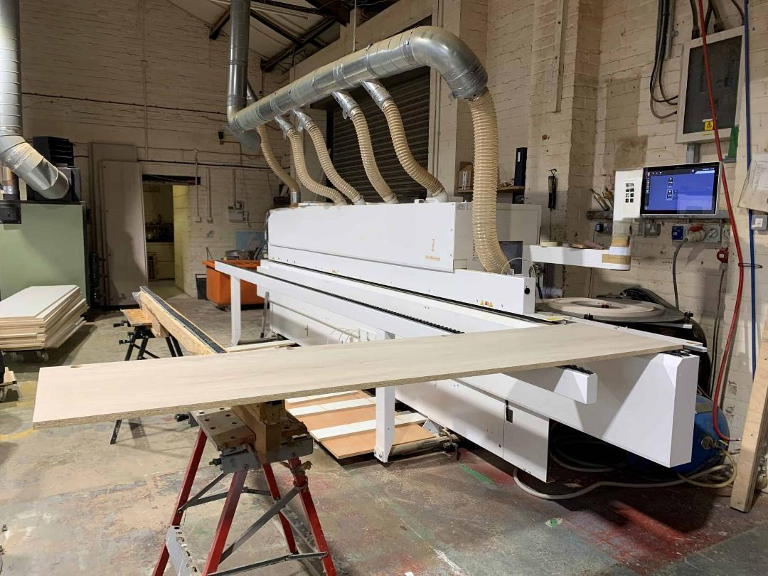

Educational furniture supplier teams often work directly with schools to meet evolving needs. In hospitality, guest expectations drive innovation. A bespoke furniture manufacturer must always stay ahead. From layout to materials, every choice supports the larger setting. Using cut and edged panels allows suppliers to match style with speed. These panels help create cohesive, modern looks that last. Not all factories are alike. A cut and edge panel factory operates with unique precision. Machines are calibrated to handle repeated tasks, which boosts efficiency. This is key for both an education furniture supplier and a hotel furniture manufacturer. Volume orders require predictability. Custom designs demand flexibility. Whether producing for classrooms or guest rooms, factories must adjust. A hospitality furniture supplier might work with short deadlines. Educational furniture companies might request sturdy, child-safe finishes. In all cases, the factory ensures each order is consistent and meets standards. They bridge the gap between design and delivery. Creativity blends with practicality in this industry. A custom furniture manufacturer must balance form and function. The best ones never compromise. They consider space, use, and feel.

A bespoke furniture manufacturer often deals with clients seeking unique themes. That calls for innovative cuts and finishes. Using cut and edge services helps maintain smoothness and uniformity. It simplifies assembly and improves final presentation. Clients often return to the same hotel furniture supplier because of trust. That trust is built on consistency, design clarity, and support. Whether furnishing a learning space or a luxury suite, makers shape experiences. Each project brings new challenges. From mass-produced items to handcrafted pieces, variety is key. An education furniture manufacturer works closely with schools to suit their curriculum needs. A hotel furniture company might be designing a boutique feel. These spaces must be inviting, efficient, and safe. With the help of hospitality furniture suppliers, many businesses turn concepts into completed environments. The cut and edge process plays a silent but crucial role. It improves speed and finish. Working with a reliable custom furniture supplier makes all the difference. It’s a network of makers, united by care and craft.

