Facts About Web Design Companies

Having a strong digital presence is more important than ever. Businesses grow when their website, content, and visibility align. That’s where web design companies play a key role. They build sites that look good and work well. A clean, modern design keeps visitors interested. The right web design company knows how to guide users smoothly. Many web design agencies now create sites with SEO in mind. This boosts visibility from the start. Website design companies ensure your pages are easy to use. Good design builds trust. With solid structure and thoughtful layout, your website becomes a valuable business tool. Once your site looks great, people need to find it. That’s where seo services come in. Search engines love fast, clear, well-written websites. A skilled seo expert helps you get seen online. They use keywords that match what people search for. A trusted seo company will also fix any technical issues. This helps boost your rankings naturally. A strong seo agency updates strategies based on your goals. Their job is to bring in the right traffic. These services take time, but they work. If you're looking to learn more about web design companies charlotte, take a look at mentioned above site.

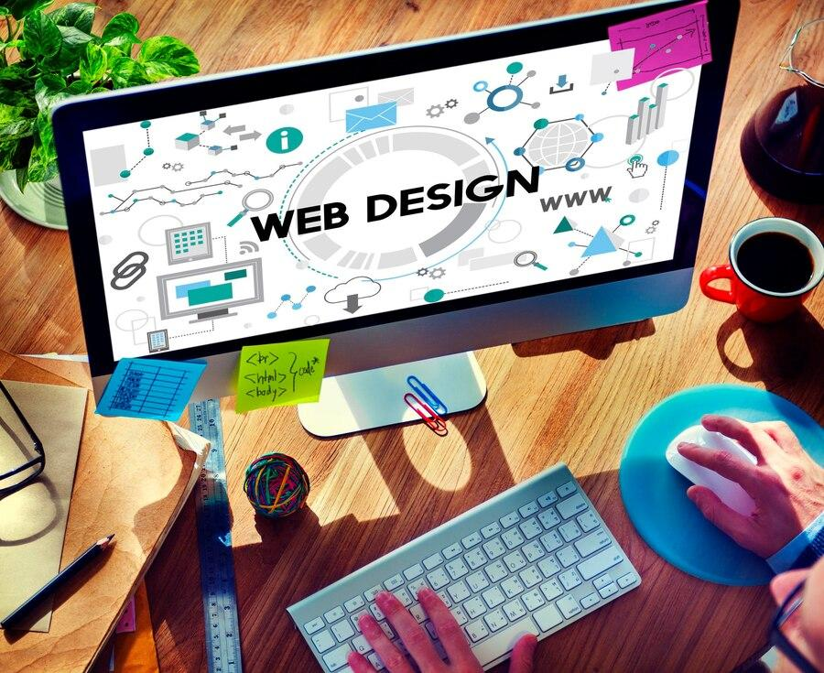

Your business shows up where it matters most—on search engine results. But people also live on social media. That’s why social media marketing is essential. It builds brand awareness and keeps you top of mind. A good social media marketing company posts content that connects with people. These posts can drive traffic to your website. Social media marketing services also support campaigns and special offers. You reach audiences in different ways. They see you often, and that builds trust. Engagement turns into visits. Visits turn into conversions. With consistent posts and strong messages, your business stays active online. It becomes easier to grow your reach over time. The real magic happens when everything works together. A reliable web design company builds a site with SEO in place. A seo expert makes that site rank higher.

A social media marketing company sends traffic to it. These efforts don’t compete—they support one another. Web design agencies can connect your blog with your socials. Seo services help improve those blog posts too. Then, social media marketing services help you promote them. This digital circle keeps your brand moving. Each part feeds the next. Together, they build a powerful online system. One that drives results again and again. Digital success comes from a smart, connected approach. Website design companies help with structure and visuals. Seo services improve visibility and reach. Social media marketing builds connection and conversation. You need all three for the best outcome. A strong seo company helps you grow organically. An experienced web design company makes every visit count. A professional social media marketing company keeps people coming back. These services may be different, but they share one goal—growth. They give your business the tools to succeed online. Together, they help you stay ahead, stay visible, and stay connected. That’s the winning digital trio.

