Details On Washing Machine Repair

It’s easy to take home appliances for granted until they stop. Regular care can help them last longer. Small efforts now save bigger problems later. Simple cleaning or careful use can do wonders. If things still go wrong, it’s best to get appliance repair. Ignoring signs might lead to permanent damage. Sudden breakdowns are frustrating. That’s why preventative steps are key. You don’t have to be an expert. Just know the basics and stay alert. Always choose reliable appliance services if you need help. Prevention gives peace of mind and keeps things running well. Start with your washer. Keep the door open after use. Wipe the rubber seal regularly. Don’t overload the drum. These steps reduce the need for early washing machine repair. Check the hoses now and then. If you're searching for more information on washing machine repair basingstoke, go to the previously mentioned site.

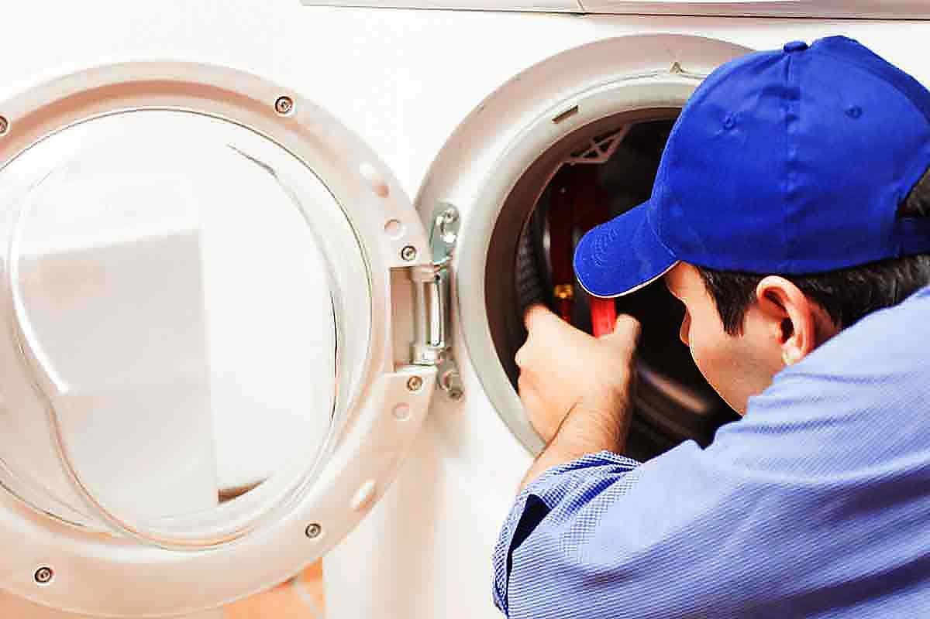

They can wear out quietly. If you spot leaks, call for help. It’s better to fix small things quickly. Regular cleaning helps the washer last longer. For combined machines, look for proper washer dryer repair. The drying part can also fail. Lint buildup can affect it. A little care goes a long way with laundry machines. Dishwashers make life easier but need care too. Rinse dishes before loading. Clean the filter weekly. It stops blockages. A blocked filter can lead to breakdowns. You might then need dishwasher repair. Check the spray arms as well. They can get clogged with food or debris. Use dishwasher cleaner monthly. It keeps the machine fresh and running well. These machines use water and electricity. So, proper upkeep matters. If it starts to smell or leaves residue, don’t wait. Professional appliance services can handle it safely. Ovens are central to any kitchen.

They need attention as well. Clean up spills after cooking. Grease build-up affects performance. If heating becomes uneven, you may need oven repair. Faulty fans or elements are common issues. A broken seal wastes energy. Keep an eye on that too. Avoid using foil at the bottom. It can block airflow. Good airflow means better cooking. Clean the oven door regularly. Visibility helps while baking. If it takes longer to heat, something is wrong. Schedule appliance repair before it worsens. Caring for your machines helps your daily routine run smoother. It saves time and prevents future stress. If something feels off, don’t ignore it. Call professionals who know washer dryer repair, dishwasher repair, and oven repair. A quick fix today avoids major costs later. Trained experts offer dependable appliance services. They also give helpful advice. Small steps keep your appliances efficient and safe. So, maintain them with care. Stay on top of any issues. That’s the best way to enjoy lasting comfort at home without constant repairs or disruptions.

