Detailed Analysis On The Wedding Venue

Planning a memorable event starts with finding the right space. Whether it's a celebration or a business event, the location matters. A stylish wedding venue sets the tone for a joyful day. For business, practical conference facilities make all the difference. Each event needs its own character. That’s why choosing a space that adapts to your needs is essential. You want a venue that reflects your style. It should be flexible, welcoming, and easy to arrange. When selecting from various wedding locations, it's not just about size. It's about how that space feels once transformed to match your vision. Every couple dreams of a perfect wedding day. They picture every detail with care. From the décor to the layout, it should feel personal. Many wedding halls are designed for this. They offer blank canvases for your creative touch. You can add flowers, lighting, and furniture to suit your taste. If you are looking for additional details on wedding venue hertfordshire, click on the mentioned above site.

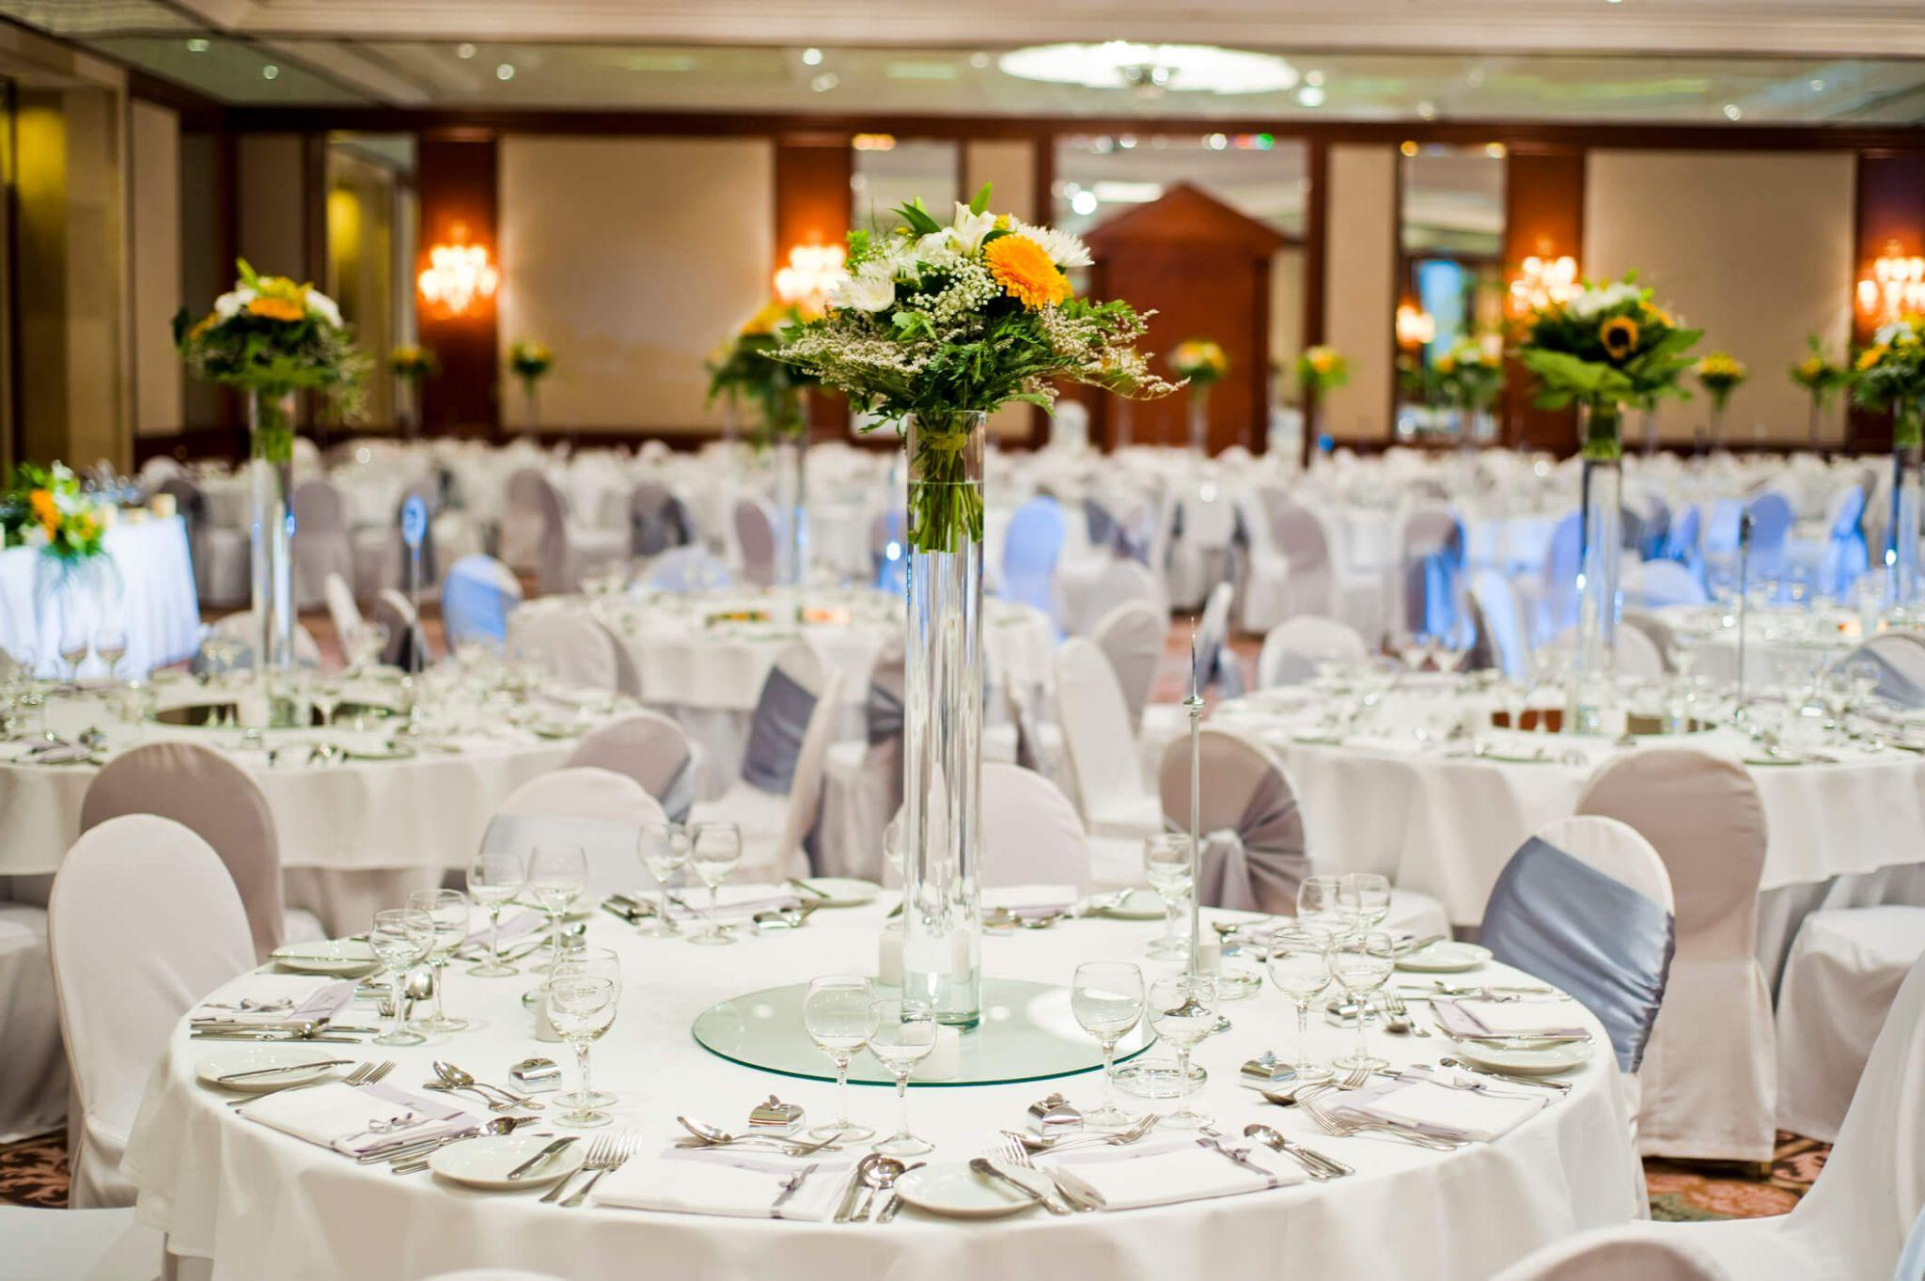

A beautiful wedding venue should feel warm and inviting. It should support your ideas, not limit them. Choosing between different wedding locations can feel overwhelming. But when a space aligns with your theme, everything flows easily. You just need the right atmosphere to bring it all together. Corporate events also need the right setting. Successful meetings begin with smart meeting room hire. A well-equipped meeting room keeps attendees focused and comfortable. Some conference centres offer full packages for easy planning. These places provide tools to help you run a smooth event. Good conference venues include audio-visual support and flexible seating. That way, you can tailor the layout to your needs. Every detail matters, from lighting to sound. Whether you need a small conference room or a large hall, comfort and clarity come first. Your guests should feel engaged, not distracted. A venue that transforms well saves time and effort. You can turn one space into many different scenes.

This makes both weddings and business events more adaptable. The beauty of modern conference facilities is their versatility. Walls can move, lights can change, and designs can shift. This allows for unique event styles in the same space. The right wedding halls can change from formal to festive quickly. When a wedding venue works around you, planning becomes less stressful. You don’t need to settle for a set look. You create the event you imagined. Choosing the right venue is about trust. You want to feel heard and supported. A team that listens helps you shape your vision clearly. From meeting room hire to full conference centres, great service makes the difference. It’s not only about the building—it’s the people who help you use it well. The same goes for wedding locations. Personalised support brings your plans to life. When spaces are designed with flexibility in mind, your event will shine. Whether you’re tying the knot or hosting a seminar, the right venue transforms your day beautifully.

