Detailed Report On Jewellery Shop Piercing

Technology is transforming the world of body modifications, offering precision, safety, and innovative designs. Many individuals now visit a jewellery shop piercing collection to explore new options enhanced by artificial intelligence. AI-driven recommendations help customers find the perfect piece based on their preferences and anatomy. This advancement ensures that piercings are not only stylish but also tailored for comfort. The integration of smart technology in jewellery design is making personalisation easier than ever. As technology evolves, body modifications are becoming more advanced, providing a seamless experience for those looking to express themselves through unique accessories. The use of AI in body piercing jewellery is improving both the selection process and the piercing experience itself. AI-powered tools can analyse facial structures and suggest ideal placements for different piercings. Virtual try-on technology allows individuals to see how a piece of body jewellery will look before making a purchase. These innovations make decision-making easier, helping customers choose jewellery that complements their style. In addition to aesthetics, AI ensures that piercings are positioned for optimal healing. Are you hunting about jewellery shop piercing? Visit the previously discussed website.

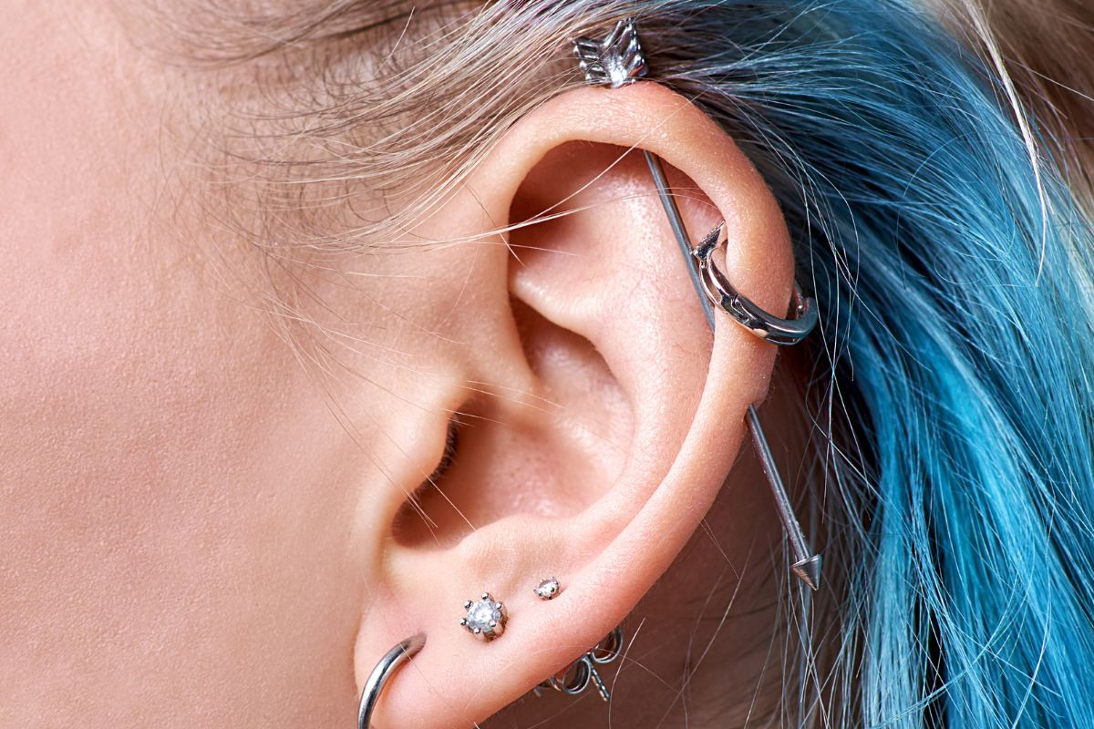

With real-time adjustments and personalised suggestions, technology is revolutionising the way people approach body modifications. Another key area where AI is making an impact is in piercing procedures. Smart piercing devices ensure accurate placements, reducing the risk of human error. Many individuals visiting a piercing shop jewellery collection now have access to automated systems that enhance safety and precision. AI-driven aftercare solutions also provide personalised healing plans, monitoring progress and offering real-time advice. These advancements are making piercings safer and more comfortable. By integrating AI into the process, professional piercers can enhance their expertise, ensuring a better experience for their clients. The future of piercing is shifting towards innovation and accuracy. AI is also influencing the market for nose piercings, offering a range of customised jewellery options. A well-designed nose stud can now be crafted using advanced 3D modelling, ensuring the perfect size and shape. AI-driven analytics help customers select the most flattering pieces based on their facial features. Similarly, a nose ring piercing can be tailored to fit individual preferences, providing an improved level of comfort.

The demand for personalised nose piercing jewelry continues to rise as technology makes customisation more accessible. With AI-generated recommendations, customers can effortlessly find jewellery that enhances their appearance while ensuring a secure fit. The growing use of AI in the jewellery industry is also helping brands create sustainable and ethical pieces. Smart sourcing techniques allow manufacturers to track materials, ensuring ethical production practices. Shopping at a piercing jewellery store now offers a wider variety of responsibly crafted designs that cater to modern consumers. AI assists in optimising production processes, reducing waste, and improving the durability of jewellery. This shift towards technology-driven sustainability is shaping the future of body modifications. As awareness grows, customers are seeking pieces that not only look great but also align with their values. The impact of AI on body jewellery is undeniable, providing precision, safety, and innovation in every aspect. From selecting the perfect piece to ensuring a seamless piercing experience, technology is enhancing the way people modify their bodies. AI-powered solutions allow for better decision-making, improved healing, and sustainable practices. As advancements continue, the possibilities for customisation and comfort will expand even further. Whether choosing a simple stud or a bold statement piece, technology is making it easier than ever to achieve the perfect look. The future of body modifications is now driven by intelligence and creativity.

