Closer Look On Video Content Production

In today's competitive market, businesses need innovative and engaging ways to connect with their audiences. One of the most powerful tools for achieving this is through video content. Creative video marketers are experts at developing content that not only captures attention but also drives meaningful engagement. By using visually appealing storytelling and strategic messaging, these professionals help businesses craft videos that leave a lasting impression. This approach ensures that every video resonates with the target audience, leading to increased brand visibility and customer loyalty. A creative video studio plays a crucial role in bringing ideas to life. These studios combine expertise in production techniques with a deep understanding of a brand's messaging. Whether it's a corporate video, social media clip, or a promotional film, a creative video studio can deliver top-notch production quality. The team’s collaboration and experience ensure that the final product meets the brand’s objectives while keeping the audience engaged. If you are seeking for additional details on video content production london, take a look at previously mentioned site.

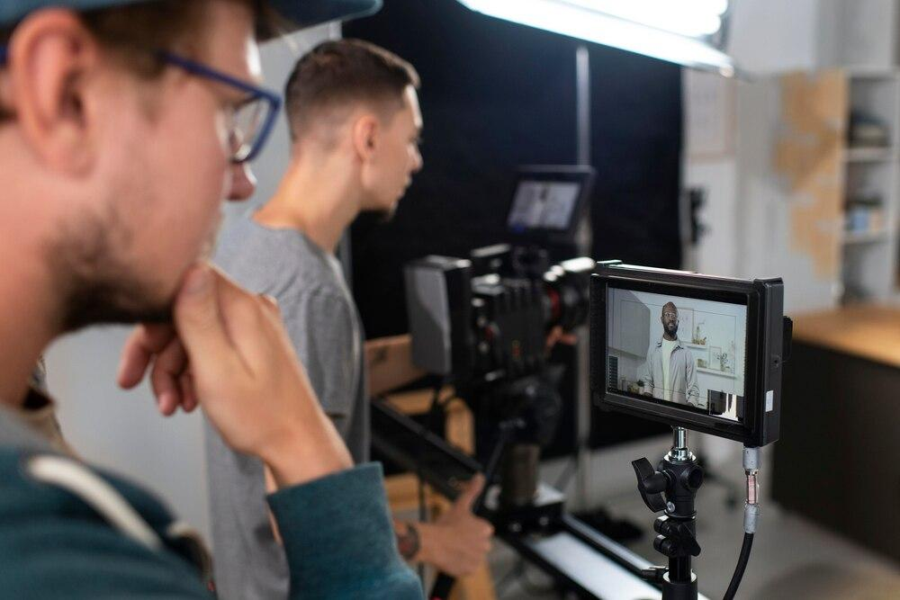

Working with such a studio ensures that the video content is polished, professional, and impactful, standing out from the crowd in a world saturated with visual content. Video content production involves more than just filming; it’s about crafting a compelling narrative that speaks to the audience. A well-produced video has the power to communicate complex ideas in a digestible, engaging manner. This could include animations, interviews, or product showcases that highlight the best aspects of a brand. With proper planning and expert production, video content can become an invaluable asset, improving brand awareness, attracting potential customers, and increasing sales. High-quality production ensures that businesses get the most out of their investment in video content. Collaborating with creative video marketers is an investment that can provide long-term benefits. These experts help guide the process from concept to completion, ensuring that the final product aligns with the brand's goals. Their expertise in targeting the right audience and selecting the most effective platforms for distribution increases the chances of success.

By outsourcing video production to a team of creative marketers, businesses can focus on their core operations while benefiting from the marketing power of professionally produced content. For companies looking to elevate their marketing efforts, a creative video studio offers an opportunity to work with skilled professionals who can bring creative ideas to life. The studio’s team is responsible for translating a company’s vision into a video that captures its essence. With the right blend of creativity and technical know-how, video content can become a central part of a brand's identity, helping it stand out in the marketplace. Whether it’s for a social media campaign or a full-scale advertising effort, the studio’s expertise ensures that every video serves its purpose effectively. In conclusion, video content production is a crucial part of any modern marketing strategy. By collaborating with creative video marketers and a creative video studio, businesses can produce engaging, high-quality video content that strengthens their brand and captures the audience’s attention. These video professionals are skilled at creating content that not only entertains but also communicates key messages in a way that is impactful and memorable. Investing in video content production is a powerful way for brands to enhance their marketing efforts and stay ahead of the competition.

