An Overview Of Fire Door Maintenance

Regular inspections and servicing are essential to ensure fire doors function effectively in an emergency. A well-structured fire door maintenance routine helps identify issues such as damaged seals, misaligned frames, or faulty hardware. Fire doors must remain fully operational to contain fire and smoke, protecting occupants and property. Working with a reputable fire door company ensures compliance with safety regulations and provides expert guidance on maintaining fire doors. Proper maintenance includes checking door closers, hinges, and intumescent seals, as any defects could compromise the door’s performance and put lives at risk in the event of a fire. Fire doors must be installed correctly to perform their intended function. Hiring a certified fire door installer guarantees compliance with safety standards and ensures doors are fitted securely. Poor fire door installation can lead to gaps around the frame, allowing smoke to spread unchecked. Regular inspections should focus on alignment, closing speed, and latch engagement to ensure doors operate correctly. Fire doors that do not fully close or have missing components should be repaired or replaced immediately to maintain fire safety standards. Are you searching about fire door maintenance london? Browse the previously discussed site.

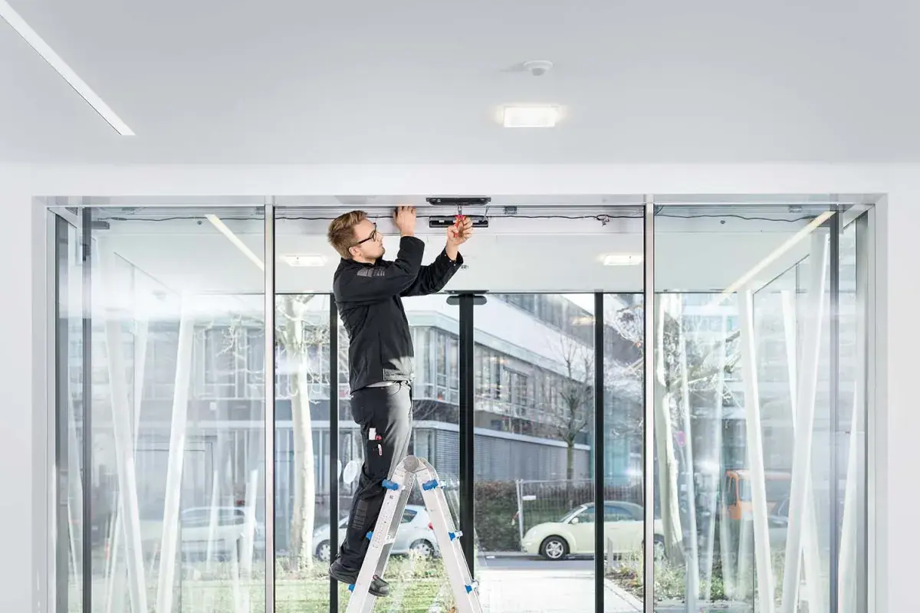

Property owners are responsible for ensuring fire doors remain in optimal condition. Beyond fire doors, additional fire protection measures must be in place to prevent fire spread. Fire stopping installation is a crucial element in sealing gaps around pipes, cables, and ductwork, reducing fire and smoke passage. Partnering with experienced fire stopping companies ensures high-quality materials are used for effective fire containment. Fire-stopping solutions include fire-resistant sealants, wraps, and intumescent products that expand in extreme heat. These measures work in conjunction with fire doors, creating a complete fire protection system. If fire-stopping measures are not properly installed or maintained, fire safety can be significantly compromised. To ensure compliance, professional assessments should be conducted by qualified fire stopping installers who can identify weak points in a building’s fire protection system. Reliable firestopping contractors provide solutions tailored to specific building requirements, preventing fire from spreading through unprotected openings. Fire safety regulations require that all passive fire protection systems be regularly checked and maintained. A failure to meet these requirements can result in penalties or legal repercussions. Property owners must schedule inspections and address any defects immediately to remain compliant with fire safety legislation.

Engaging professional fire door installation contractors is essential for businesses and property owners who want to ensure their buildings meet fire safety regulations. Choosing accredited fire door installers guarantees that fire doors are installed and maintained to the highest standards. Routine servicing should include lubrication of hinges, checking door leaf integrity, and ensuring the self-closing mechanism functions properly. Fire doors are an integral part of any fire protection strategy, and their maintenance should never be neglected. Regular checks help prevent fire doors from failing during an emergency, ensuring they function effectively when needed most. In high-traffic buildings, investing in commercial fire door installation is crucial to safeguarding employees, customers, and assets. Fire doors are designed to withstand high temperatures and create a barrier against flames and smoke. Their performance depends on correct installation, regular servicing, and prompt repairs when necessary. A well-maintained fire protection system can save lives, prevent property damage, and ensure compliance with legal fire safety requirements. Partnering with fire safety professionals for inspections, repairs, and installations is the best way to maintain a reliable and effective fire protection system.

