Advantages Of BI And ERP

Data-driven decision-making has become a necessity for businesses seeking to stay competitive in an evolving marketplace. With the growing volume of information available, integrating big data and ERP systems has become essential for turning raw data into actionable insights. Businesses now leverage advanced tools to process large datasets efficiently, gaining a deeper understanding of customer behaviour, operational efficiencies, and market trends. By combining enterprise resource planning with analytics, organisations can improve decision-making, enhance productivity, and predict future demands. The integration of scalable cloud ERP solutions ensures that businesses can adapt to changing data needs without the limitations of outdated infrastructure. The ability to scale operations is crucial for any organisation aiming for long-term success. Traditional systems often struggle to handle increasing data loads, making cloud ERP scalability a game-changer for businesses looking to expand. Unlike legacy software, modern cloud-based platforms offer flexibility, ensuring seamless growth without requiring extensive hardware upgrades. The debate between on premise ERP vs cloud ERP continues, but cloud solutions provide real-time access to analytics, enabling teams to make informed decisions from anywhere. If you're looking to learn more about bi and erp, explore the above website.

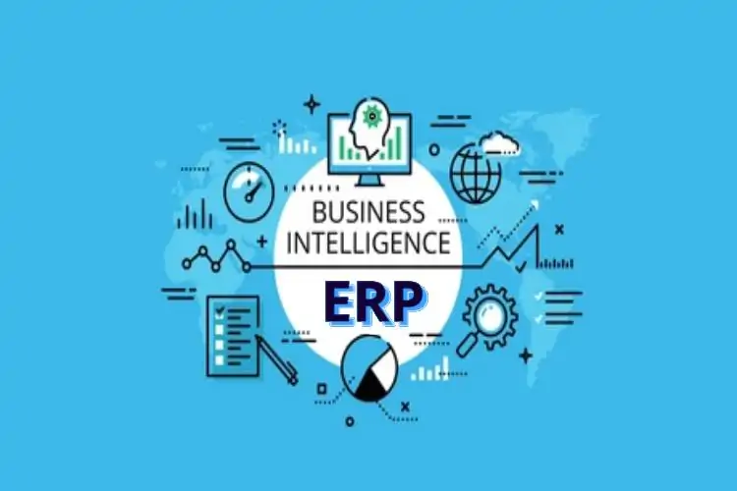

This level of accessibility transforms business operations, allowing enterprises to maintain agility in a fast-paced digital environment. Integrating analytics into enterprise resource planning enhances visibility across all business functions. The role of business intelligence in ERP is to ensure that data is not just collected but used strategically. By embedding analytics within ERP platforms, companies can track performance metrics, identify inefficiencies, and optimise workflows. The collaboration between BI and ERP enables leaders to make proactive choices, reducing risks and improving operational efficiency. Through predictive analysis, businesses can anticipate market shifts, adjust supply chain strategies, and align resources effectively, ensuring long-term stability and growth. Choosing between cloud ERP vs on premise ERP remains a key decision for companies aiming to modernise their operations. While on-premise solutions provide direct control over infrastructure, they often require high maintenance costs and manual updates. In contrast, cloud based ERP vs on premise comparisons highlight the advantages of cloud solutions, such as automatic updates, cost savings, and improved security. These systems facilitate seamless data integration across departments, ensuring that organisations maintain a unified approach to managing critical information.

By adopting cloud-based platforms, companies enhance collaboration and increase efficiency, leading to better overall performance. As data volumes continue to expand, the need for comprehensive analytics grows. The integration of bi ERP system solutions enables companies to convert raw figures into meaningful insights, empowering decision-makers with accurate forecasts. By leveraging ERP and data analytics, organisations can streamline financial reporting, monitor supply chain efficiency, and improve customer experiences. These tools ensure that businesses remain data-driven, avoiding costly mistakes and capitalising on emerging opportunities. With a well-implemented analytics strategy, companies gain a competitive edge, driving profitability and fostering innovation. Businesses must embrace technological advancements to remain competitive, and integrating scalability and cloud ERP solutions is a step toward future-proofing operations. The fusion of big data and ERP provides a robust framework for decision-making, allowing organisations to act swiftly and strategically. By implementing intelligent ERP systems, businesses gain real-time insights, improve efficiency, and enhance overall agility. As industries evolve, leveraging these tools will be key to sustaining growth and achieving long-term success in an increasingly data-driven world.

