A Glimpse At Gynecomastia Surgery

Many men struggle with the emotional and physical impact of gyno, a condition that leads to the enlargement of the chest. It often causes distress, leading individuals to hide their bodies under loose clothing to avoid embarrassment. The shame associated with this condition can affect confidence, social interactions, and even mental well-being. Some try to manage it through diet and exercise, but these methods often prove ineffective if the underlying cause is not weight-related. For those looking for a permanent solution, gyno surgery offers a way to regain confidence and feel comfortable in their own skin again. Living with gynecomastia can be challenging, as it often leads to self-consciousness and avoidance of activities that involve removing one’s shirt, such as swimming or working out. This can further isolate individuals and affect their social life. The stigma around this condition may prevent many from seeking professional help, leaving them to suffer in silence. However, medical advancements have made gynecomastia surgery a safe and effective option. If you're looking for more information on gynecomastia surgery, just go to the previously mentioned site.

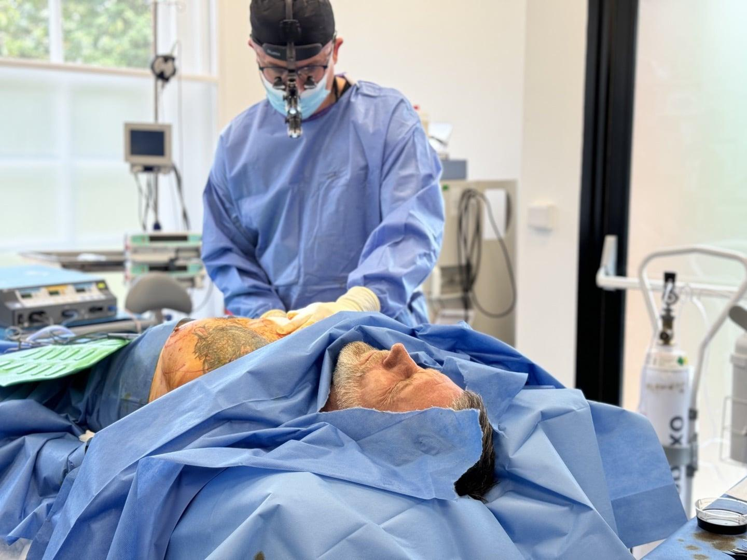

Consulting a qualified gynecomastia doctor can provide reassurance and guidance on the best approach for each individual case. Many men spend years attempting to conceal their gynaecomastia, often layering clothes or avoiding fitted garments. This constant effort to hide their bodies can take a toll on their self-esteem and overall happiness. The good news is that modern medical solutions, such as male chest reduction, have made it easier to address this concern permanently. By choosing a skilled gynecomastia surgeon, patients can achieve a more contoured chest and eliminate the insecurities that have held them back for years. The decision to undergo surgery is a personal one, but it can significantly improve quality of life. One of the biggest concerns men have when considering gynecomastia surgery is the recovery process and potential risks. Advances in surgical techniques have minimised downtime, with most patients returning to their daily routines within a few weeks. The key is to choose the best gynecomastia surgeon, ensuring a smooth and successful procedure. Clinics specialising in this field, such as Harley gynecomastia clinic, provide expert care and tailored treatment plans. With proper aftercare and adherence to medical advice, patients can achieve natural-looking results and a renewed sense of self-confidence.

The psychological impact of living with gynecomastia should not be underestimated. Many men experience anxiety, depression, or feelings of inadequacy due to their appearance. Addressing this issue through gyno surgery not only improves physical aesthetics but also enhances mental well-being. By taking proactive steps and consulting an experienced professional, individuals can break free from the cycle of shame and insecurity. It is important to remember that seeking treatment is not about vanity but about reclaiming confidence and comfort in one’s own body. The journey towards self-acceptance begins with acknowledging the issue and taking steps to resolve it. Ultimately, no one should feel the need to hide behind their clothes or avoid situations due to gyno. Modern medical advancements offer effective and lasting solutions that can restore confidence and eliminate the distress associated with this condition. By choosing a reputable gynecomastia surgeon and undergoing a well-planned procedure, men can experience a significant transformation in both appearance and self-esteem. The decision to seek treatment is an empowering one, allowing individuals to embrace life fully without the burden of insecurity. Overcoming the shame of gynaecomastia is possible, and with the right support, lasting change can be achieved.

