The Value Of Event Production Companies

Organising a successful event requires careful planning, and one of the biggest challenges is managing technical aspects. Many people overlook the importance of proper equipment and end up facing disruptions. Working with event production companies can help mitigate potential issues and ensure a seamless experience. Technical failures, poor sound quality, and inadequate lighting are common problems that can negatively impact an event. Whether it is a corporate function, a concert, or a private gathering, having the right event production services in place can make a significant difference in delivering a professional and engaging atmosphere for attendees. One major issue that event planners face is poor sound quality. Whether it is a microphone cutting out or distorted audio, these problems can distract audiences and make communication difficult. To avoid this, using reliable audio visual hire services ensures high-quality sound systems tailored to the venue size. Selecting the right av equipment hire option is crucial to achieving clear and consistent audio. Testing equipment before the event and having backup systems available can prevent unexpected failures. Additionally, working with an experienced event production company can provide professional support to manage sound issues effectively. If you are looking for additional details on event production companies london, look into the previously mentioned website.

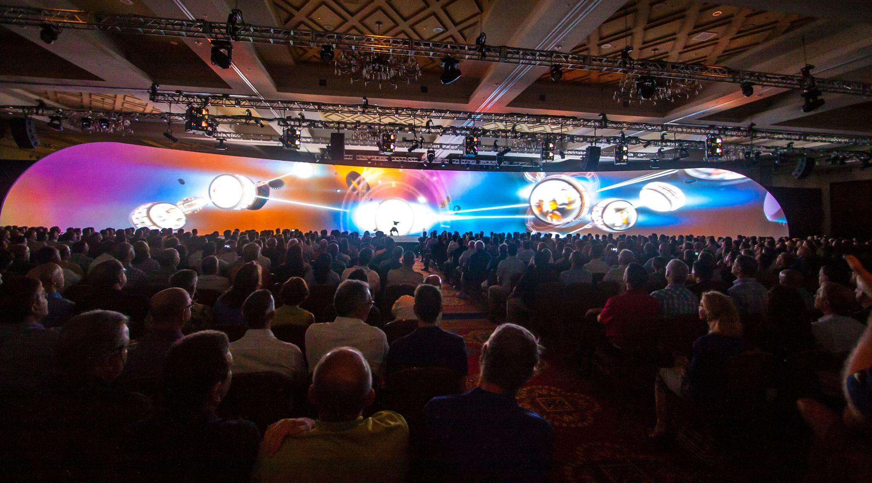

Another frequent challenge is inadequate lighting, which can impact the mood and visibility of an event. Poor lighting can make it difficult for speakers to be seen or performers to engage with the audience. Choosing professional lighting hire solutions allows for the creation of the right ambience and enhances the overall experience. Whether it is decorative lighting for a wedding or stage lighting hire for a live performance, having the right setup is essential. Testing different lighting angles and intensities before the event helps in avoiding any last-minute surprises that could affect the presentation. Equipment malfunctions are another major concern for event organisers. Technical failures can cause significant delays and frustration among guests.
Having a plan in place for audio visual equipment hire ensures that high-quality gear is used and is regularly maintained to prevent breakdowns. Partnering with reliable event production services also means access to professional technicians who can troubleshoot issues on the spot. This proactive approach reduces the risk of disruptions and ensures that the event runs smoothly. Backup equipment should always be available in case of an unexpected failure. Another common problem is a lack of coordination between different technical aspects. Sound, lighting, and visuals must work together seamlessly for a flawless event. Without proper planning, elements may not be synchronised, leading to an unprofessional outcome. Working with event production companies that specialise in full-service solutions can help avoid this. They handle everything from av hire to event lighting hire, ensuring that all components function as a cohesive unit. A detailed run-through before the event can help identify and resolve any potential issues before they become major problems. Successful event planning requires attention to detail, especially regarding technical aspects. Avoiding common disasters involves using professional event production solutions, reliable audio visual hire services, and expert guidance for event lighting and staging. Testing equipment, ensuring proper coordination, and having contingency plans in place are essential steps. By taking these precautions, event organisers can provide a high-quality experience for attendees without the stress of unexpected technical failures. Investing in quality event production services is key to ensuring a memorable and hassle-free occasion.

