Precise Study On The Stretcher Earrings

Body modifications have gained widespread popularity, with ear stretching being one of the most recognisable trends. Over time, individuals have explored different ways to express themselves through body jewellery and stretching techniques. Many start their journey with an ear stretching kit, which provides the necessary tools to achieve a gradual and safe stretch. While lobes remain the most commonly stretched area, some enthusiasts experiment with other body parts. Whether for cultural significance or personal style, stretching has evolved beyond a niche trend and into a mainstream form of self-expression. A proper stretching routine requires patience, the right tools, and high-quality jewellery. A gauge stretching kit includes tapers and plugs of various sizes, helping individuals stretch their lobes in controlled increments. Choosing a surgical steel ear stretching kit can prevent irritation and reduce the risk of infection. Beginners often start with a ear stretching kit beginners, ensuring a smoother transition through different sizes. Proper aftercare is essential to avoid complications like blowouts or excessive scar tissue, which can result from stretching too quickly or using poor-quality jewellery. Browse the following site, if you are hunting for more information about stretcher earrings.

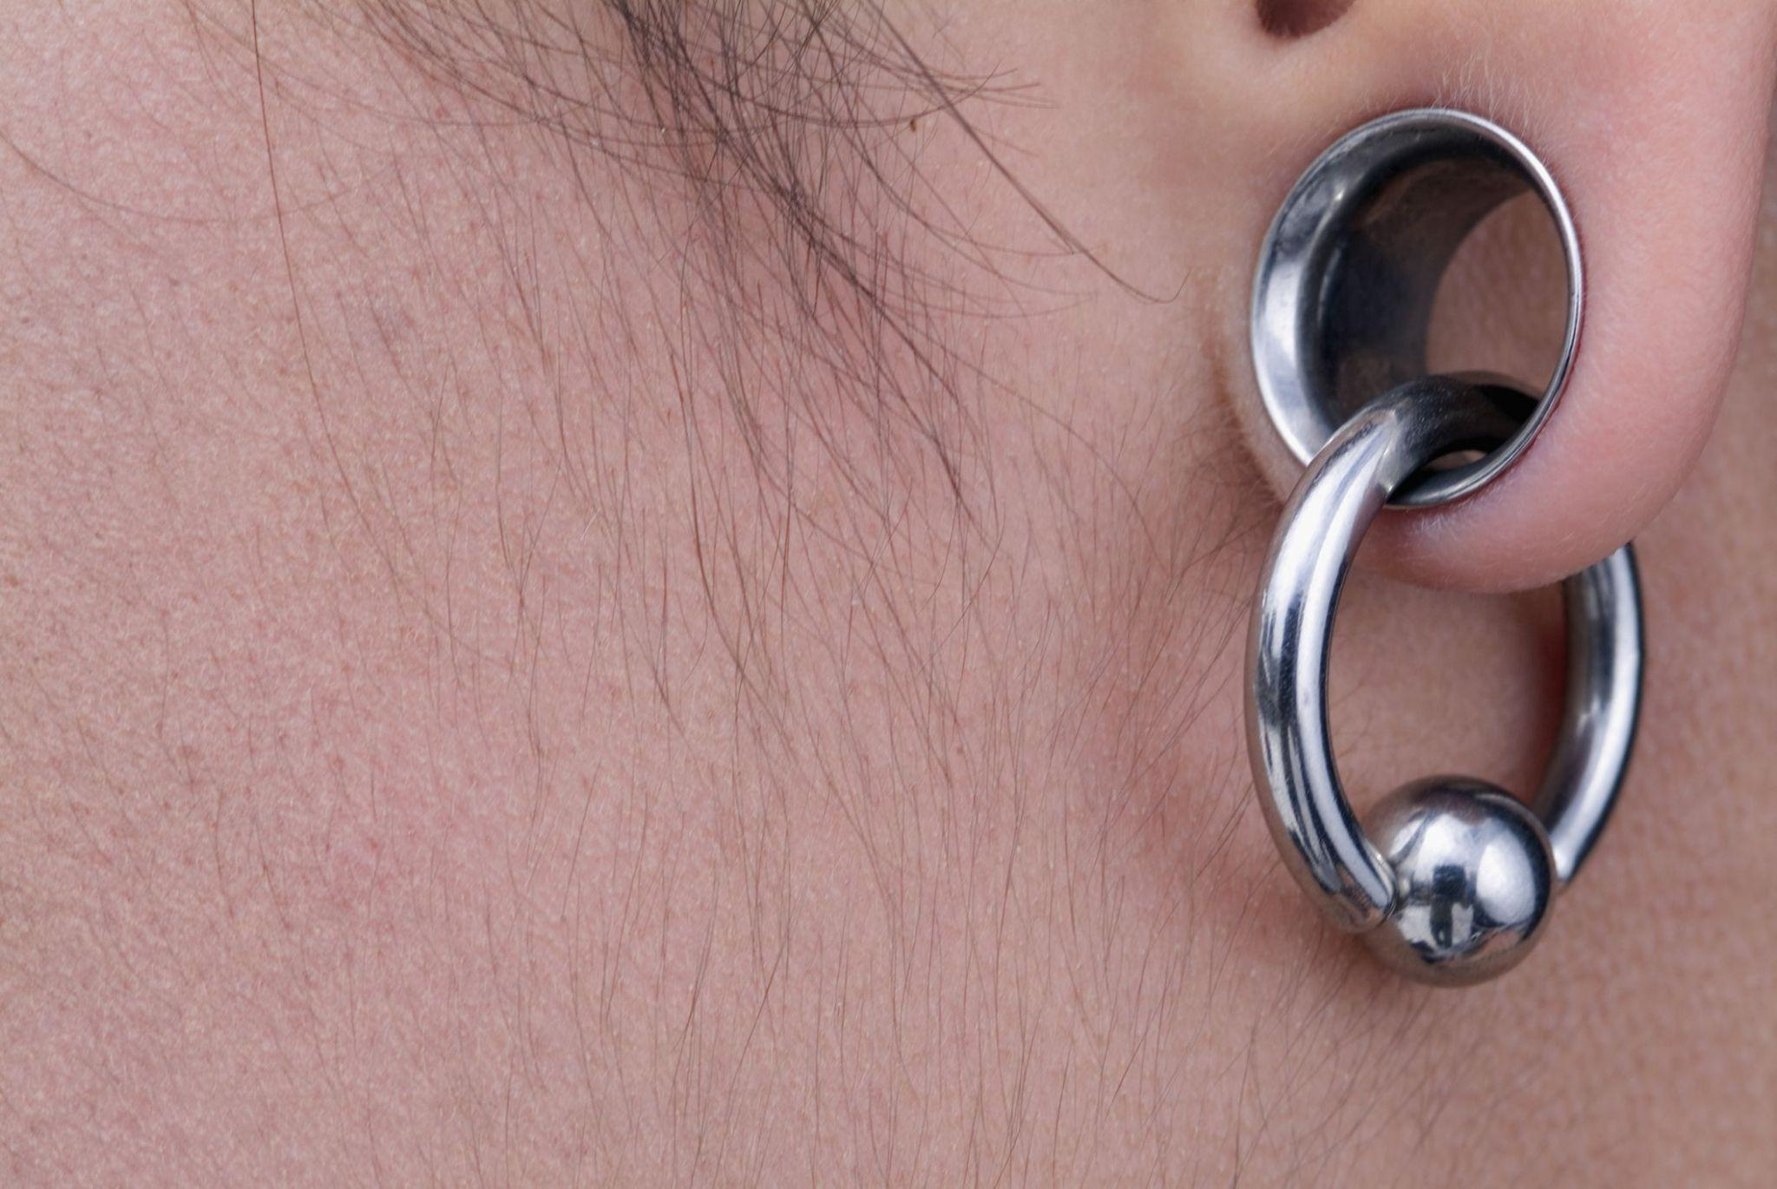

As body modifications gain acceptance, more people are incorporating stretcher earrings into their everyday style. The availability of unique stretch earrings designs has allowed individuals to personalise their appearance in new ways. A earlobe stretching kit makes it easy for those interested in achieving a gradual stretch without causing unnecessary damage. With the right technique, stretched ears can be both a stylish and long-lasting statement. The transition from traditional earrings to stretched lobes requires time and commitment, but the results can be incredibly rewarding for those who embrace the process. For those seeking a bold look, investing in the best ear stretching kit ensures a smooth and safe experience. The quality of jewellery plays a key role in preventing irritation and discomfort. A large ear stretching kit is ideal for those aiming for significant expansion over time, offering a variety of sizes to progress at a safe pace.
Stretching beyond standard sizes requires careful planning, as larger gauges take longer to heal. Those who rush the process often experience setbacks, making patience an important aspect of successful body modification. Starting with a ear stretching starter kit helps newcomers understand the process before committing to larger sizes. The availability of different stretching kit gauges ensures that individuals can select the best fit for their needs. More people are now exploring stretching techniques beyond lobes, experimenting with septum, nostril, and cartilage stretching. These practices require specialised jewellery and careful stretching techniques to maintain the integrity of the tissue. As body modification continues to evolve, new trends and styles emerge, keeping the practice fresh and exciting for those who embrace it. The increasing popularity of body stretching reflects a broader acceptance of alternative fashion and self-expression. A stretching kit allows individuals to explore their creativity through body modifications while ensuring safety throughout the process. With more high-quality stretching kits available, enthusiasts can select jewellery that matches their aesthetic and comfort level. Stretched piercings remain a bold statement, appealing to those who seek a distinctive and unconventional look. Whether opting for small or large gauges, the art of stretching continues to evolve, blending tradition with contemporary fashion trends.

