Detailed Analysis On Wall Printing Specialists

The world of printing has evolved significantly, moving beyond traditional paper-based materials to incorporate innovative textures, metallic finishes, and interactive elements. These advancements allow businesses to create eye-catching designs that engage customers in new ways. Whether used for marketing materials, packaging, or wall graphics, these modern techniques help brands stand out in a competitive marketplace. Companies like Wallace Print specialise in high-quality printed solutions that go beyond standard designs, offering unique finishes that enhance the overall visual and tactile experience. With the right combination of textures and effects, printed materials can leave a lasting impression on their audience. One of the most exciting innovations in the industry is the use of textured printing, which adds depth and dimension to designs. Raised patterns, embossed elements, and UV spot coatings create a tactile experience that draws customers in and encourages interaction. This technique is particularly effective for luxury branding, where a premium feel is essential. When applied to wall graphics printing, textured finishes can make surfaces more visually appealing, enhancing the atmosphere of retail spaces, offices, and exhibitions. By using these advanced methods, brands can reinforce their identity while delivering an immersive experience for their audience. Are you hunting for wallace printing? View the before discussed site.

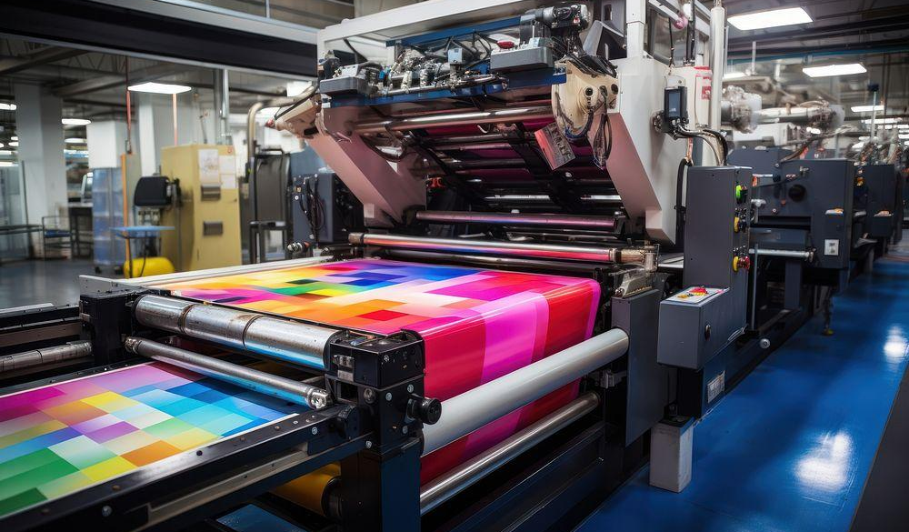

Metallic and foil stamping techniques have also gained popularity, adding a sophisticated and high-end look to printed materials. Gold, silver, and holographic foils create a striking contrast against matte backgrounds, drawing attention to key elements such as logos, typography, or design accents. This effect is commonly seen in business cards, invitations, and packaging, but it is also being integrated into wall graphics to create stunning visual displays. Businesses that invest in these enhancements ensure their branding remains memorable and impactful, capturing the interest of customers in both physical and commercial spaces. Another major advancement in modern printing is the integration of interactive elements such as augmented reality (AR).
By embedding scannable codes or invisible ink into printed materials, businesses can bridge the gap between print and digital media. Customers can scan these elements with their smartphones to unlock exclusive content, videos, or virtual experiences. This technology is particularly useful for product packaging, advertisements, and wall graphics, as it enhances engagement and encourages deeper interaction with the brand. Companies like Wallace Printing help businesses implement these features effectively, ensuring that printed materials remain relevant in a digitally driven world. The combination of innovative materials and cutting-edge techniques is transforming the way brands communicate with their audience. Businesses now have the opportunity to create truly unique printed materials that go beyond standard flat designs. Whether through textured finishes, metallic accents, or interactive elements, these enhancements elevate the perceived value of a brand and create a more engaging experience. In retail and corporate environments, wall graphics printing with these effects can make a bold statement, reinforcing brand identity while enhancing the aesthetic appeal of a space. Investing in these advancements ensures that printed materials remain a powerful tool for marketing and branding. As the industry continues to evolve, businesses must embrace the latest trends to maintain a competitive edge. Companies that explore textured printing, metallic effects, and interactive elements can create dynamic and memorable designs that capture attention. Providers like Wallce Printers offer expertise in these advanced techniques, helping brands develop high-quality materials that leave a lasting impact. By integrating these innovations into their marketing strategies, businesses can redefine how they engage with their customers, making print an even more effective medium in the digital age.

